

M.Sc. Computer Science and Engineering

Hypermedia Applications Project



Design Report

[plug-it.herokuapp.com](https://plug-it.herokuapp.com)

Leoni Luca 10574709

Minotti Luca 10572239

Ratti Francesco 10640265

**GitHub Repository**: [www.github.com/lucagrammer/Plug-IT](http://www.github.com/lucagrammer/Plug-IT)

28th June 2021

Version 1.0

**Abstract**

*Plug-IT* is a medium-sized Italian company operating in the ICT sector that needs a website to show the information related to its services. The goal of this document is to provide a functional and visual description of the website to be implemented. In particular, it aims at describing the main design choices through models, schemas and use case scenarios. Furthermore, it will also present the structure of the database from both a conceptual and logical viewpoint.

**Authors**

**Francesco Ratti**

*MSc Computer Science and Engineering*

[francesco2.ratti@mail.polimi.it](mailto:francesco2.ratti@mail.polimi.it)

+39 3342546426



**Luca Minotti**

*MSc Computer Science and Engineering*

[luca2.minotti@mail.polimi.it](mailto:luca2.minotti@mail.polimi.it)

+39 3315228707



**Luca Leoni**

*MSc Computer Science and Engineering – EIT Digital Human Computer Interaction and Design*

[luca3.leoni@mail.polimi.it](mailto:luca3.leoni@mail.polimi.it)

+39 3484124137



Contents

Introduction 5

Requirements 5

Purpose 5

1. Conceptual Design 6

1.1. Content Design 6

**1.1.1.** **C-IDM Diagram** 6

**1.1.2.** **Content Tables** 7

1.2. Navigation Design 8

**1.2.1.** **Content tables - pages mapping** 8

**1.2.2.** **P-IDM Diagram** 10

2. Visual Design 11

2.1. Home Page 11

2.2. Single Topic Pages 13

2.2.1. About Page 13

2.2.2. Contacts Page 15

2.3. Introductory Pages 17

2.3.1. People Page 17

2.3.2. Areas Page 19

2.3.3. Our Services Page 20

2.3.4. Events Page 22

2.4. Multiple Topic Pages 24

2.4.1. Person Page 24

2.4.2. Area Page 26

2.4.3. Service Page 28

2.4.4. Event Page 30

2.5. Transition Pages 32

2.5.1. Area Team Page 32

2.5.2. Service Team Page 34

3. Interaction Scenarios 35

3.1. Use Case 1 35

3.2. Use Case 2 37

3.3. Use Case 3 39

3.4. Use Case 4 41

3.5. Use Case 5 44

Database Design 46

3.6. Entity-Relationship Diagram 46

3.7. Relational Tables 47

**Introduction**

**Requirements**

*Plug-IT* is a medium-sized Italian company operating in the ICT sector that needs a website to make itself known and to show its offers. The system must show all the information relating to the *areas* (more than 3) in which it operates and the related *services* (more than 30) it offers.

In addition to the *general description* of the company and its contacts, all information about the *people* (more than 20) working at *Plug-IT* must be shown in detail.

In particular, some relationship must be evident on the website:

* People are related to areas (and vice versa) in different ways, e.g., because they are responsible for an area or because they work in an area
* People are related to services (and vice versa) in different ways, e.g., because they are project manager or because they are reference for assistance for a service
* Services are related to the areas they belong to (and vice versa)

**Purpose**

The goal of this document is to provide a functional and visual description of the website to be implemented. In particular, it aims at describing the main design choices through models, schemas and use case scenarios. Moreover, it will also present the structure of the database from both a conceptual and logical viewpoint.

1. **Conceptual Design**

The conceptual design of the website is detailed in this chapter. In particular, the choices relating to the contents, their mapping into pages and the navigation between them will be explained in detail in the following.

* 1. **Content Design**

This section describes the *C-IDM (Content Interaction Dialogue Model)*, which is a model that represents the website in terms of a dialogue between the human and the application. In particular, it explains what the dialogue is about and how the subjects of conversation are classified, mutually related and grouped. It also provides information on what can be said about each of these categories.

* + 1. **C-IDM Diagram**

The core of the model consists of the three main kind of topic *Services*, *People* and *Areas* that are interrelated. The kind of topic *Areas* consists of all the fields in which the company operates. For each of them, there is a responsible and at most fourteen other workers. Every *Area* is also associated with at least four services. Each *Service* employs a project manager and has multiple references for assistance. Furthermore, the diagram highlights the association between the people and the areas in which they operate. Another kind of topic concerns the *Events* organized by the company: they regard a specific area and generally involve one or two employees. Finally, the schema contains other two single topics: the first concerns a general description of *Plug-IT* while the other one deals with how to reach or contact the company.

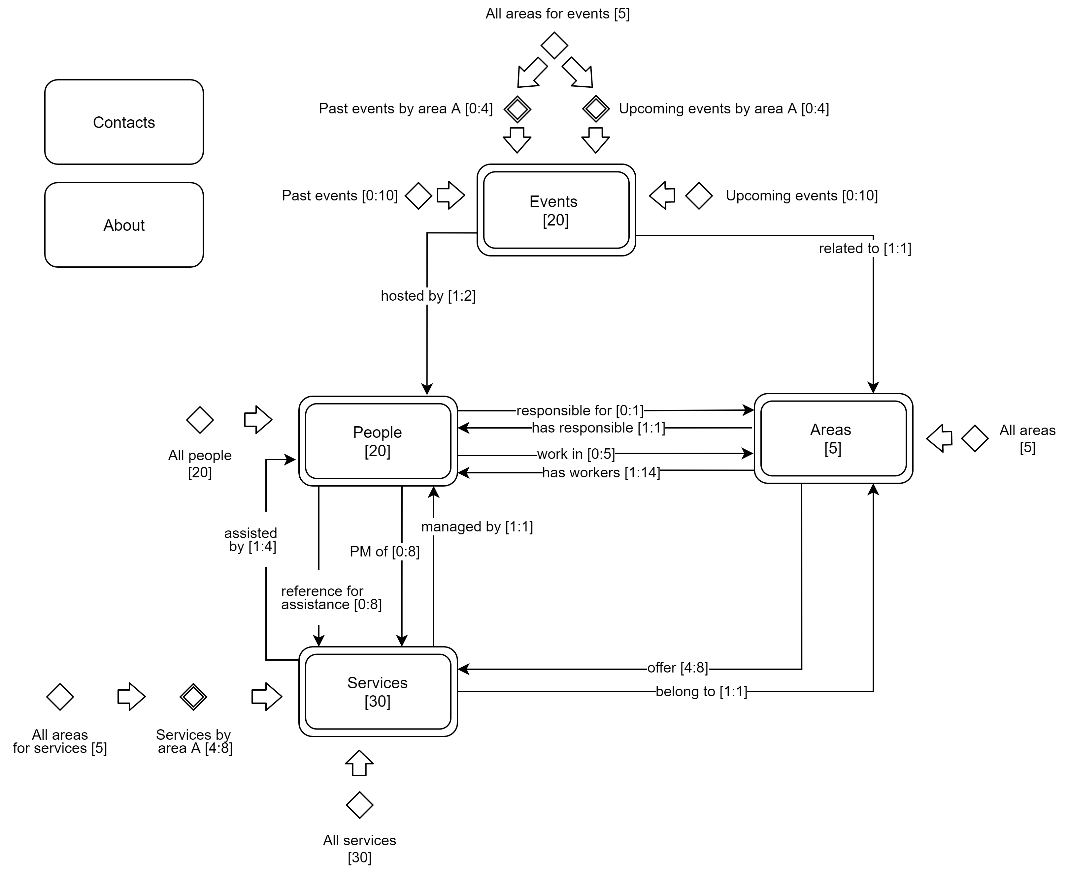

*C-IDM in-the-large diagram*

* + 1. **Content Tables**

In the following tables are defined the contents of the conversation between the human and the application for each category of subject.

|  |
| --- |
| **KIND OF TOPIC:** *People* |
| Employee name: text |
| Position name: text |
| Employee photo: image |
| Employee bio: text (max. 200 words) |
| List of managed areas [area name] |
| List of services [service name, area name, employee role] |

|  |
| --- |
| **KIND OF TOPIC:** *Areas* |
| Area name: text |
| Area overview: text (max. 250 words) |
| Area responsible (employee photo, employee name) |
| Area team: list of people [employee photo, employee name, position] |
| List of area services [service name, service slogan (max. 10 words)] |

|  |
| --- |
| **KIND OF TOPIC:** *Services* |
| Service name: text |
| Service area: text |
| Service slogan: text (max. 10 words) |
| Service description: text (max. 300 words) |
| Project manager (employee photo, employee name) |
| Reference assistants: list of people [employee photo, employee name, employee role] |

|  |
| --- |
| **KIND OF TOPIC:** *Events* |
| Event title: text |
| Event area: text |
| Event description: text (max 200 words) |
| Event hosts: list of people (employee photo, employee name, position) |
| Event details (date, time, location, map) |

|  |
| --- |
| **TOPIC:** *About* |
| Company overview: text (max. 500 words) |

|  |
| --- |
| **TOPIC:** *Contacts* |
| Office information (address, phone, fax, map) |

* 1. **Navigation Design**

This chapter describes the mapping between the content identified in the previous sections and the pages that will be implemented. Furthermore, it includes the *P-IDM (Page Interaction Dialogue Model)* diagram, which visually represents the choices made during the design of the high-level navigation topology.

* + 1. **Content tables - pages mapping**

The following tables detail the mapping of the previously identified contents into pages.

* **KIND OF TOPIC: *People***

|  |
| --- |
| **INTRODUCTORY PAGE:** *People Page* |
| People introduction: text (max. 150 words) |
| Grid of people [employee name, position, employee photo] |

|  |
| --- |
| **TOPIC PAGE:** *Person Page* |
| Employee name: text |
| Position name: text |
| Employee photo: image |
| Employee bio: text (max. 200 words) |
| List of managed areas [area name] |
| List of services [service name, service area, employee role] |

* **KIND OF TOPIC: *Areas***

|  |
| --- |
| **INTRODUCTORY PAGE:** Areas *Page* |
| List of areas [area name, short overview (max. 50 words)] |

|  |
| --- |
| **TOPIC PAGE:** *Area Page* |
| Area name: text |
| Area overview: text (max. 250 words) |
| List of area services [service name, service slogan (max. 10 words)] |

|  |
| --- |
| **TRANSITION PAGE:** *Area Team Page* |
| Area name: text |
| Area responsible (employee photo, employee name) |
| Area team: list of people [employee photo, employee name, position] |

* **KIND OF TOPIC: *Services***

|  |
| --- |
| **INTRODUCTORY PAGE:** Our Services *Page* |
| List of services [service name, area, service slogan (max. 10 words)] |

|  |
| --- |
| **TOPIC PAGE:** *Service Page* |
| Service name: text |
| Service area: text |
| Service slogan: text (max. 10 words) |
| Service description: text (max. 300 words) |

|  |
| --- |
| **TRANSITION PAGE:** *Service Team Page* |
| Service name: text |
| Project manager (employee photo, employee name) |
| Reference assistants: list of people [employee photo, employee name, employee role] |

* **KIND OF TOPIC: *Events***

|  |
| --- |
| **INTRODUCTORY PAGE:** Events *Page* |
| List of events [event name, area, date, time, short description (max. 20 words)] |

|  |
| --- |
| **TOPIC PAGE:** *Event Page* |
| Event title: text |
| Event area: text |
| Event description: text (max. 200 words) |
| Event hosts: list of people (employee photo, employee name, position) |
| Event details (date, time, location, map) |

* **TOPIC: *About***

|  |
| --- |
| **PAGE:** *About Page* |
| Company overview: text (max. 500 words) |

* **TOPIC: Contacts**

|  |
| --- |
| **PAGE:** *Contacts Page* |
| Office information (address, phone, fax, map) |

* + 1. **P-IDM Diagram**

This paragraph includes the *P-IDM (Page Interaction Dialogue Model)* diagram which shows how content is aggregated on pages and how pages of the same or different topics are linked together.

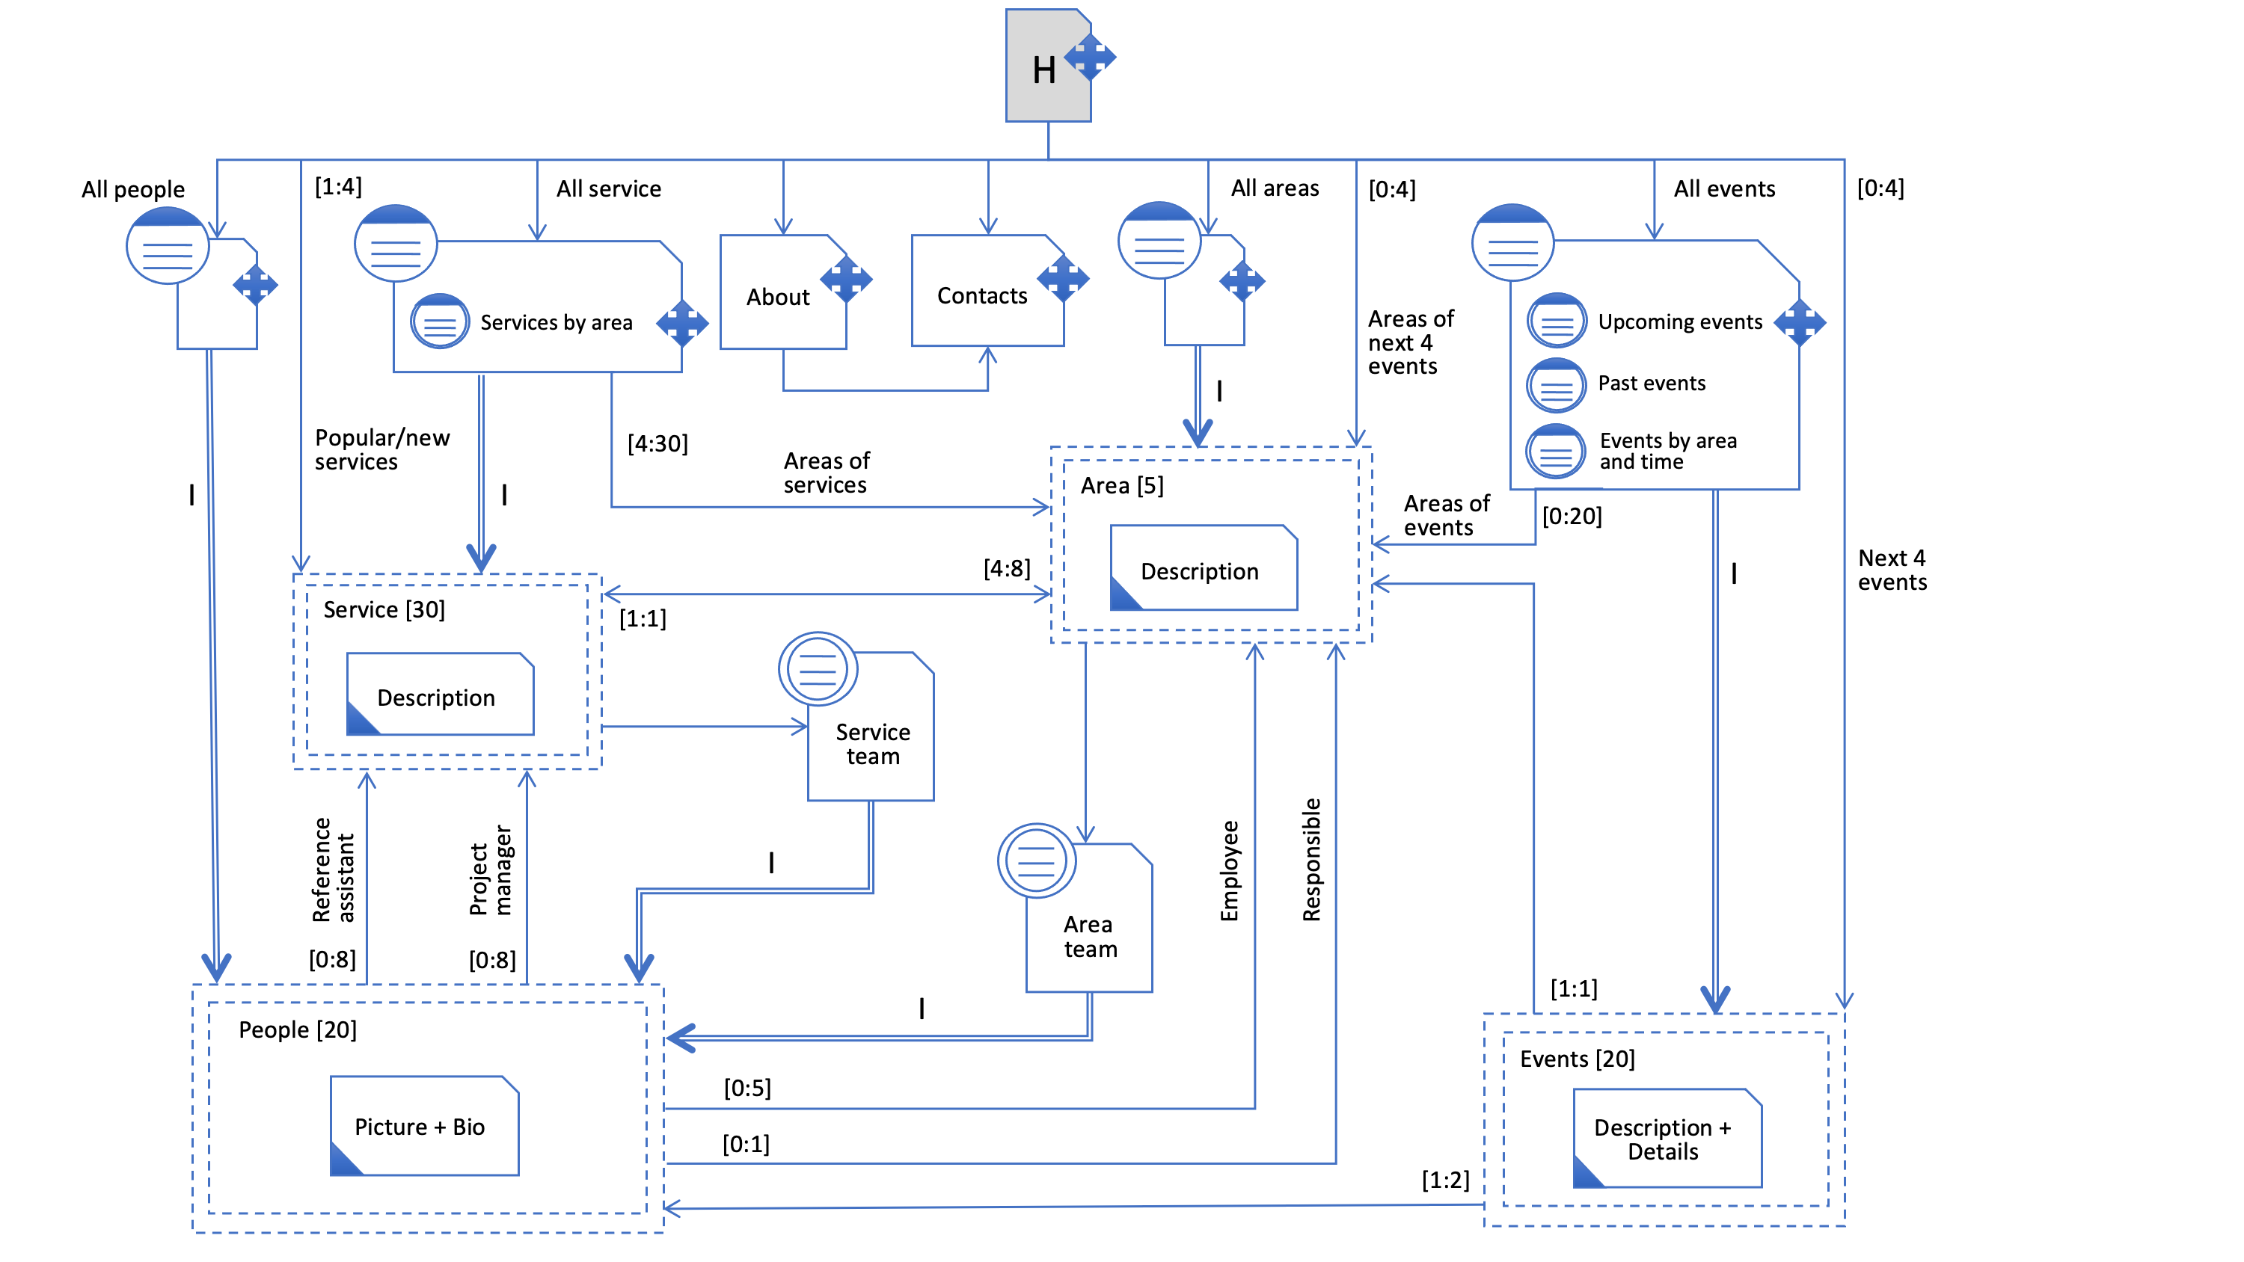

P-IDM Diagram

The landmarks of the website consist mainly of links to the introductory pages for the kind of topic *Services*, Areas, *People* and *Events*. Moreover, they enable access to the individual topics’ pages *About* and Contacts from the entire website.

As illustrated in the diagram above, the introductory page to the *People* topic allows you to navigate between the individual employees through an *index pattern*. Moreover, each person page contains *transition links* that leads to the areas or services in which the employee works.

Similarly, the group links of the introductory page for the *Areas* are organized according to the *index pattern*. The *Services*’ pages can be reached both by exploiting the *transition* *links* available in the pages of the related areas or through a dedicated introductory page (*index pattern*). The latter also allows the user to filter the results by area of belonging.

Furthermore, two *transition pages* have been provided to reach the profiles of employees involved in a specific area (*Area Team Page*) or in a specific service (*Service Team Page*).

Finally, the diagram includes also an introductory page relating to the *Events*. From the latter, the events can be filtered by area or by upcoming / past. Once again, the *group links* to the individual pages of the *Events* are managed according to the *index pattern*.

1. **Visual Design**

This chapter concerns the definition of the graphical structure of the website to be implemented. Each page will be represented via a low-fidelity wireframe and a high-fidelity prototype.

The former shows what the page offers and the basic visual organization of the content, navigation, and interaction elements on the screen. The latter defines the advanced "look and feel" of the interface, using real content. In both the representations, all the main links will be carefully highlighted.

## Home Page

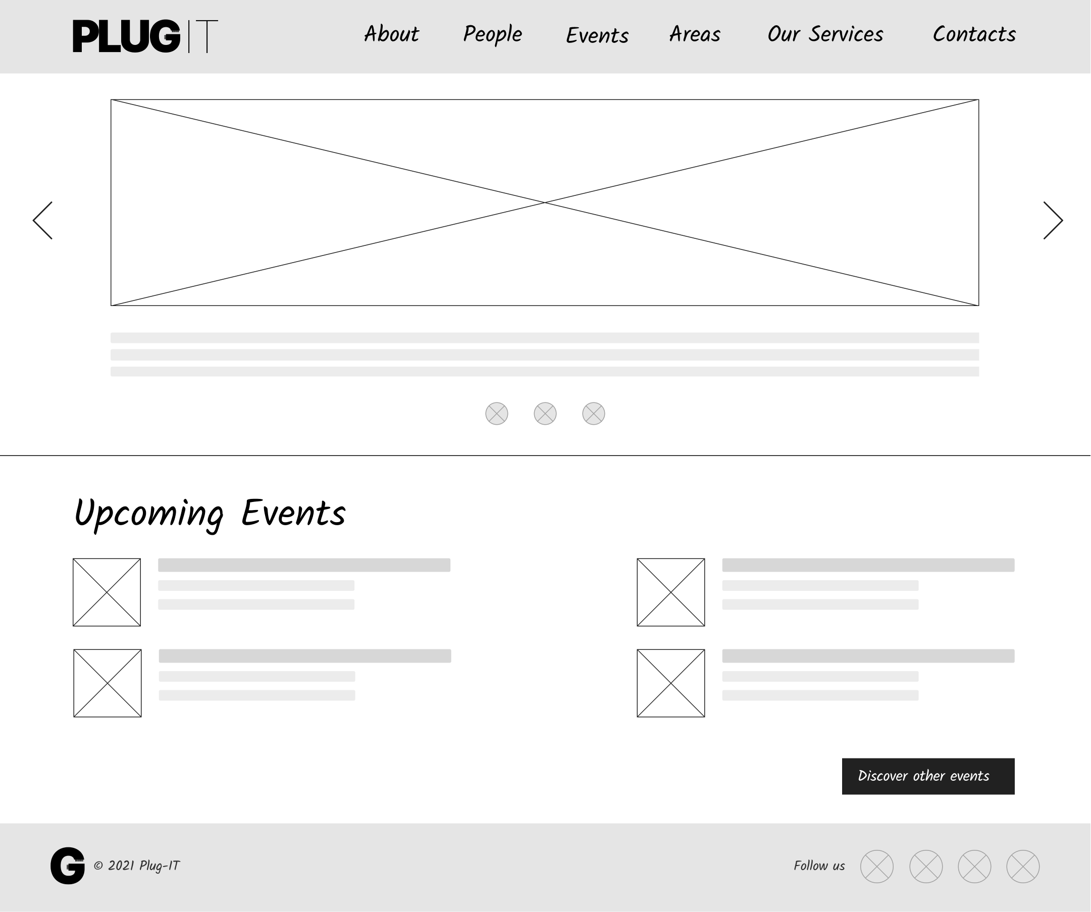

Landmarks

Transition links

Transition link

Transition links

Landmarks

Wireframe 1: Home Page

The *Home Page* is the starting point for the user experience on the website. The central communication purpose here is to establish the brand, encourage visitors to dig deeper into the rest of the site and, ultimately, convert them into loyal customers. The solution adopted for *Plug-IT* offers a summary of the website content.

As shown both in the wireframe and in the prototype, the *Home Page* is composed, at the top, of an image slider that displays an overview of the company’s most famous services and those recently added to the catalogue. Furthermore, there is a section containing *transition links* to the next four scheduled events as well as a direct link to the introductory page of the events.

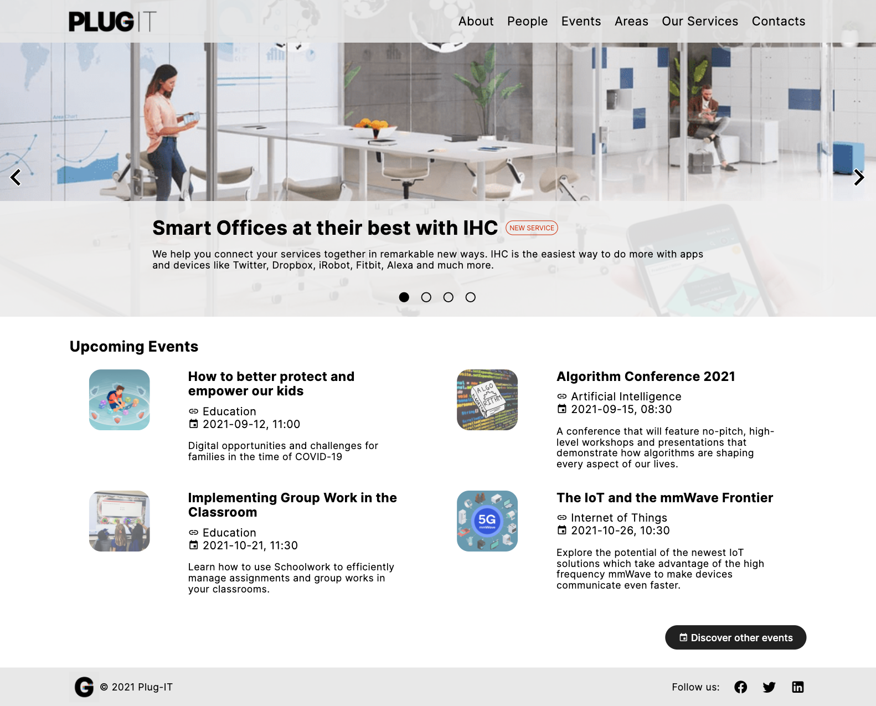

Landmarks

Transition link

Transition links

Transition links

Landmarks

Prototype 1: Home Page

## Single Topic Pages

This section describes the design choices relating to the *single topic pages*, the places where users consume contents about a single topic.

### About Page

The primary purpose of the *About Page* is to inform the reader about the company and its operations. This website’s section reports in less than 500 words the history of the organization and explains what the mission of *Plug-IT* is. The whole content is organized in several paragraphs.

Finally, at the bottom of the page, a *transition link* to the *Contacts* topic is provided.

Landmarks

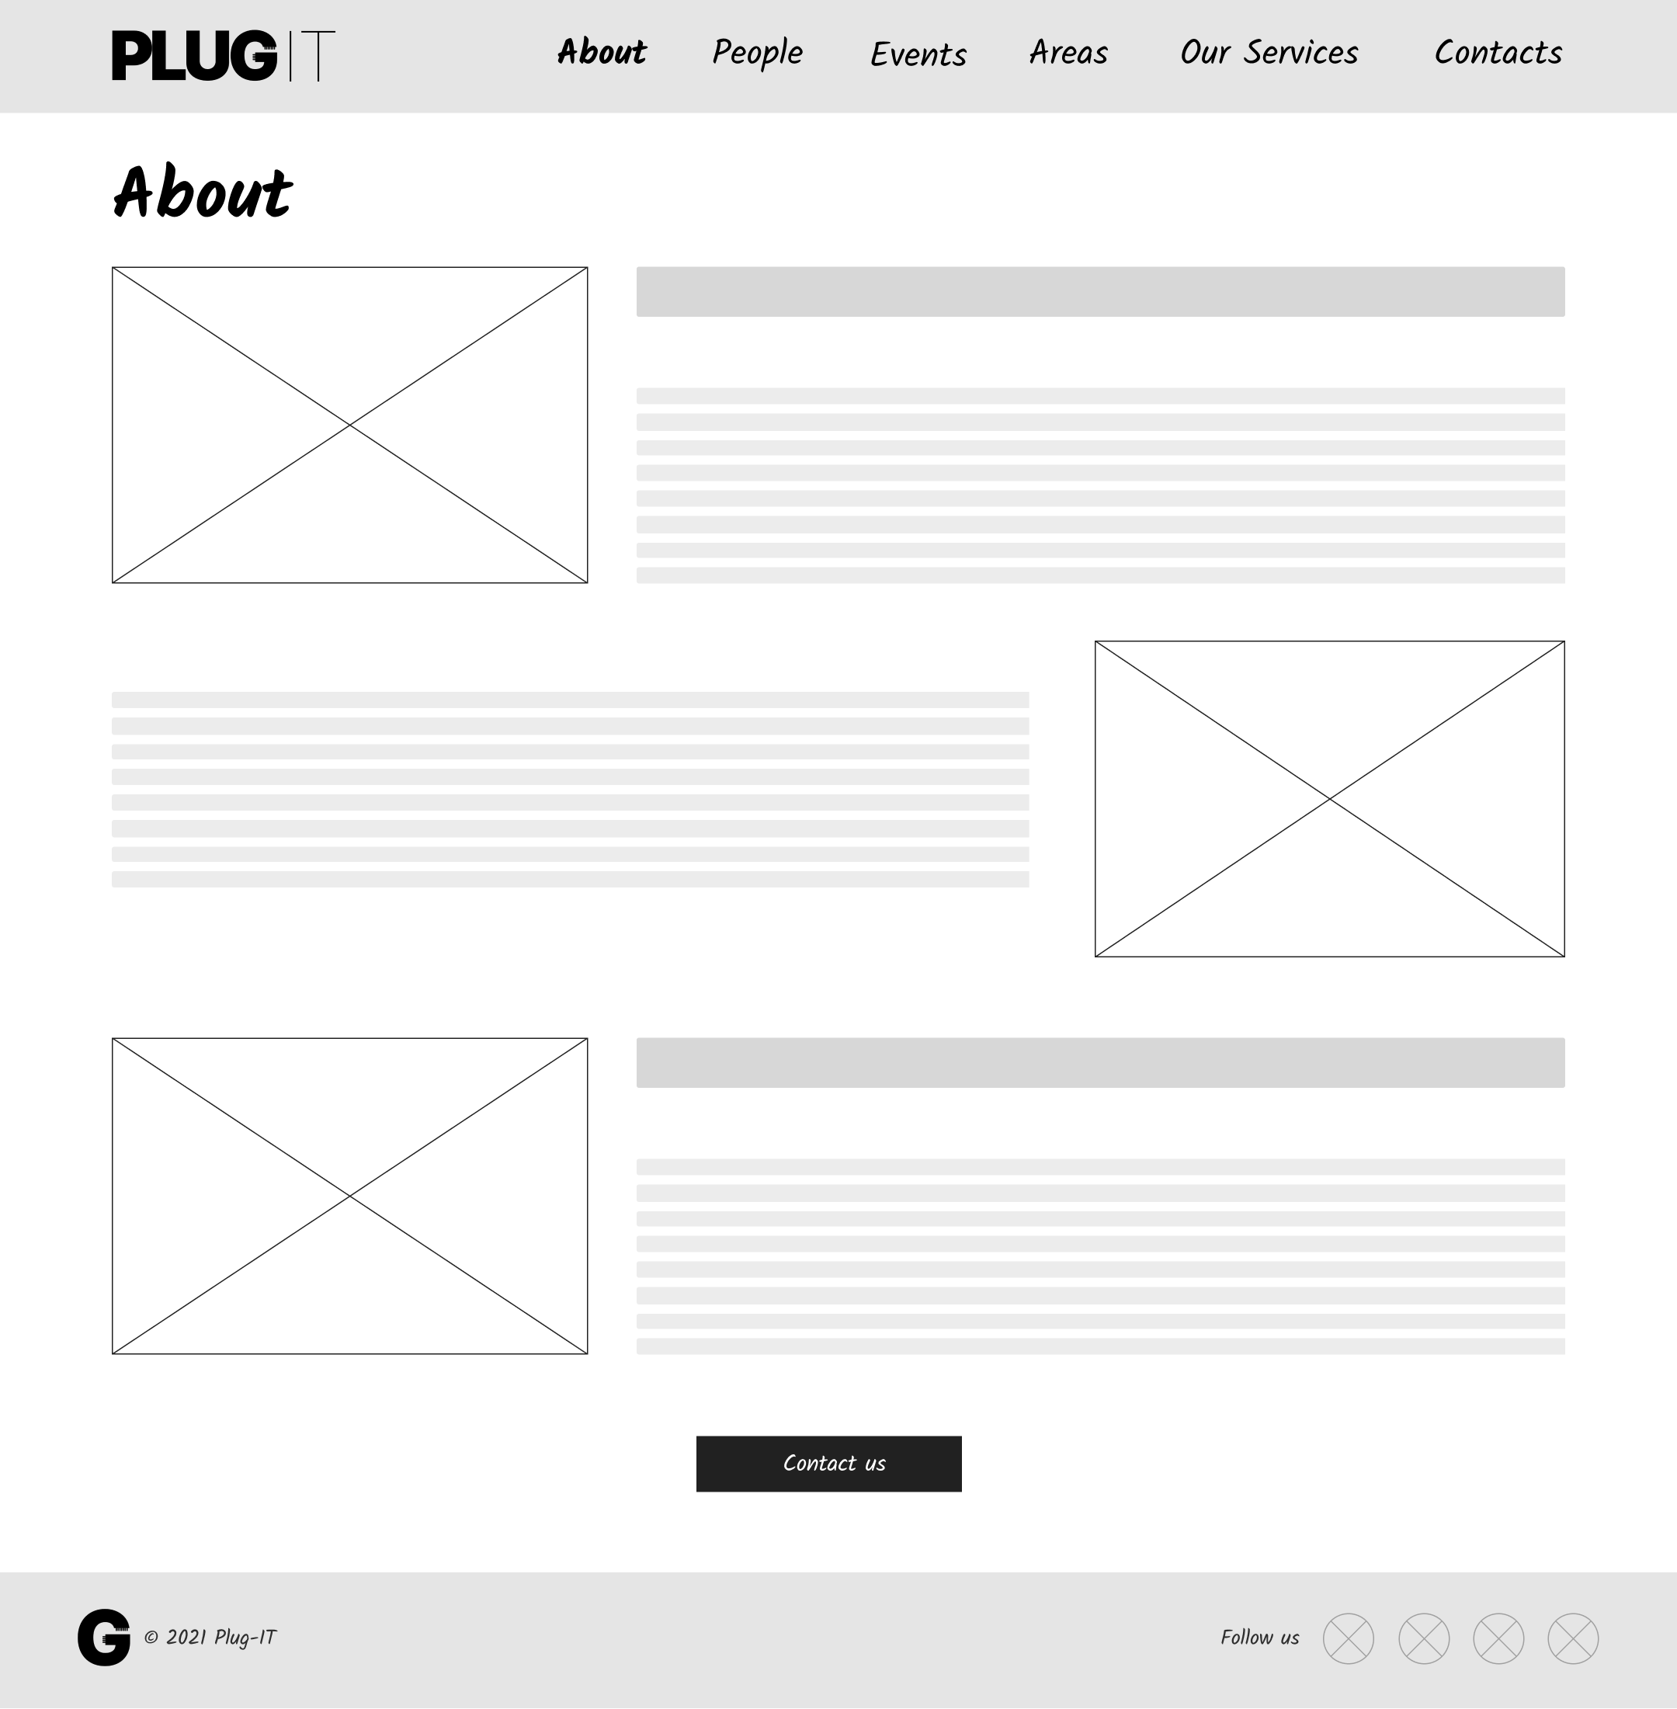

Landmarks

Transition link

Orientation info

Orientation info

Wireframe 2 – Single Topic Page: About Page

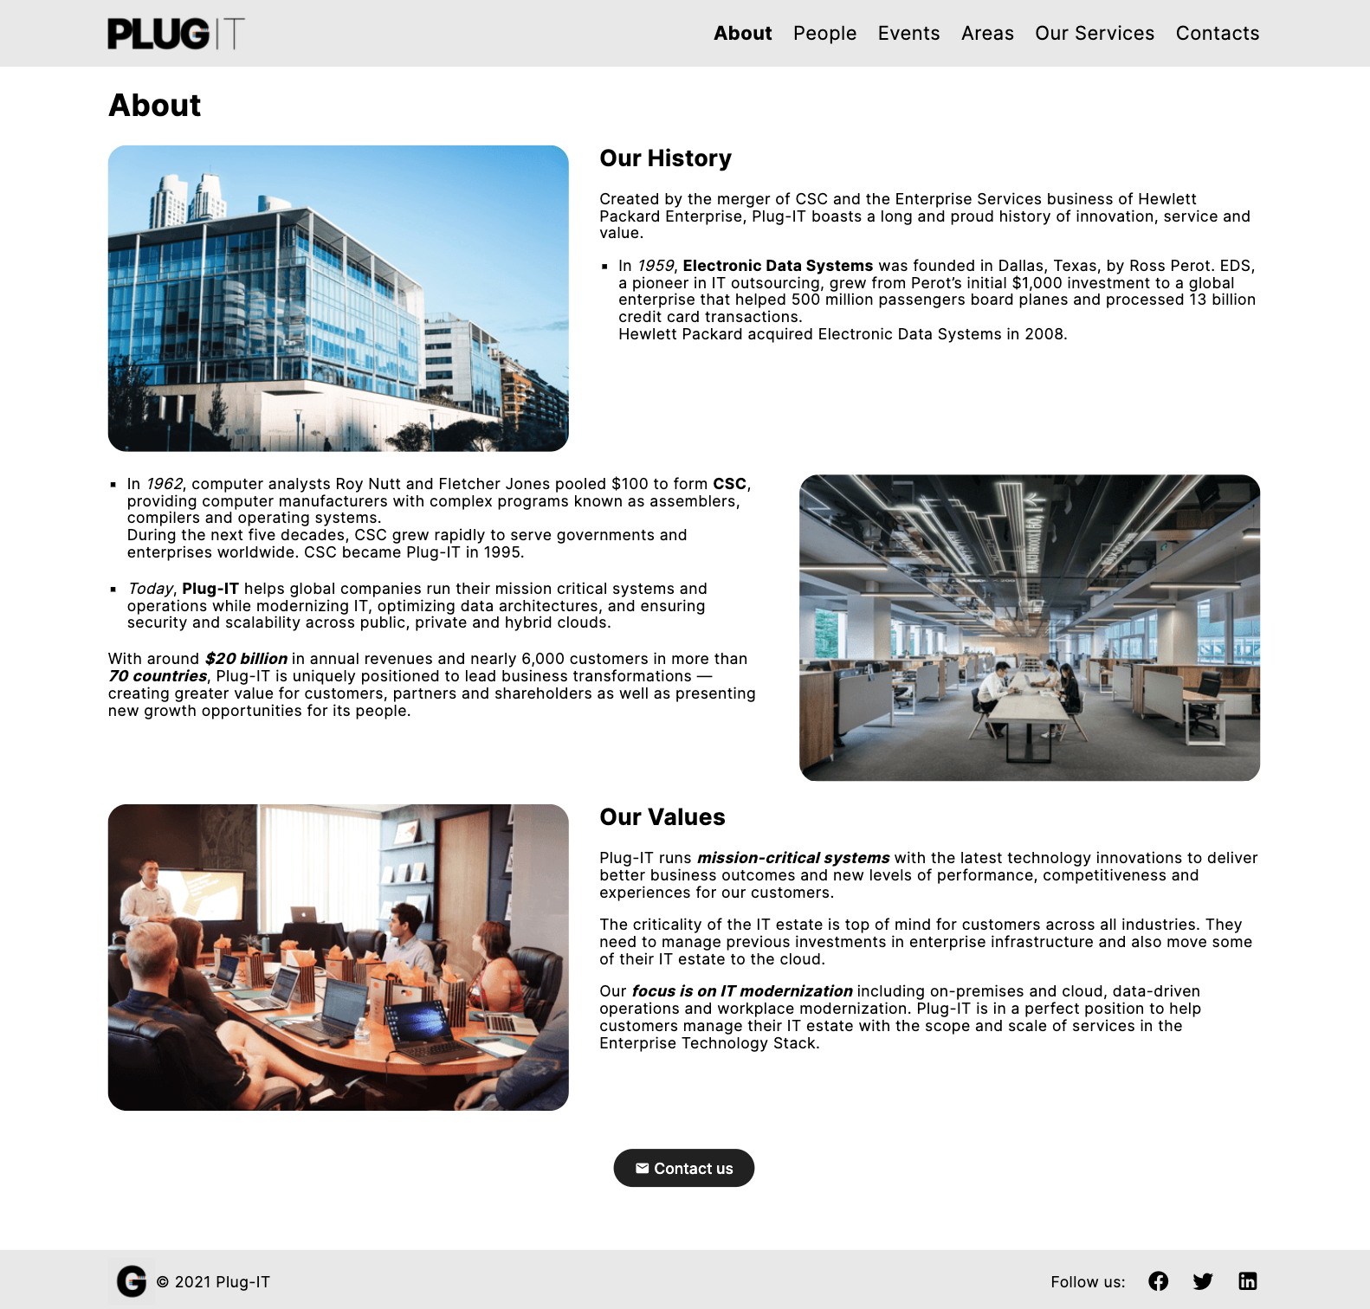

Landmarks

Transition link

Orientation info

Orientation info

Landmarks

Prototype 2 – Single Topic Page: About Page

### Contacts Page

The page dedicated to the *Contact* topic has the goal of encouraging website visitors to get in touch with the company. For this purpose, it is composed of two blocks. At the top, there is an interactive map on which the location of the *Plug-IT* headquarter is marked. The phone number, the fax contact, and the full address are also provided alongside.

The lower part of the page, instead, consists of a form through which a customer can directly send a message to the administrative offices.

Landmarks

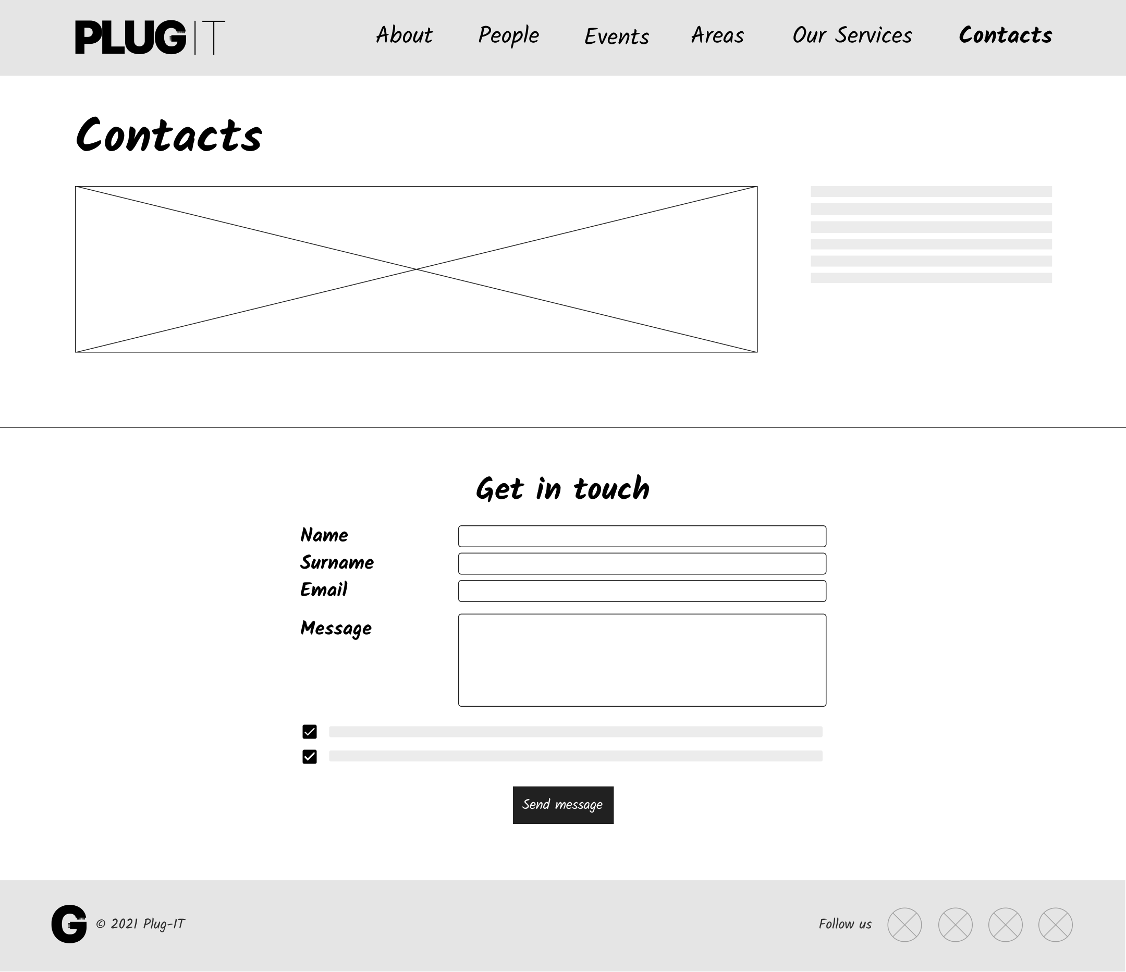

Orientation info

Landmarks

Orientation info

Wireframe 3 – Single Topic Page: Contacts Page

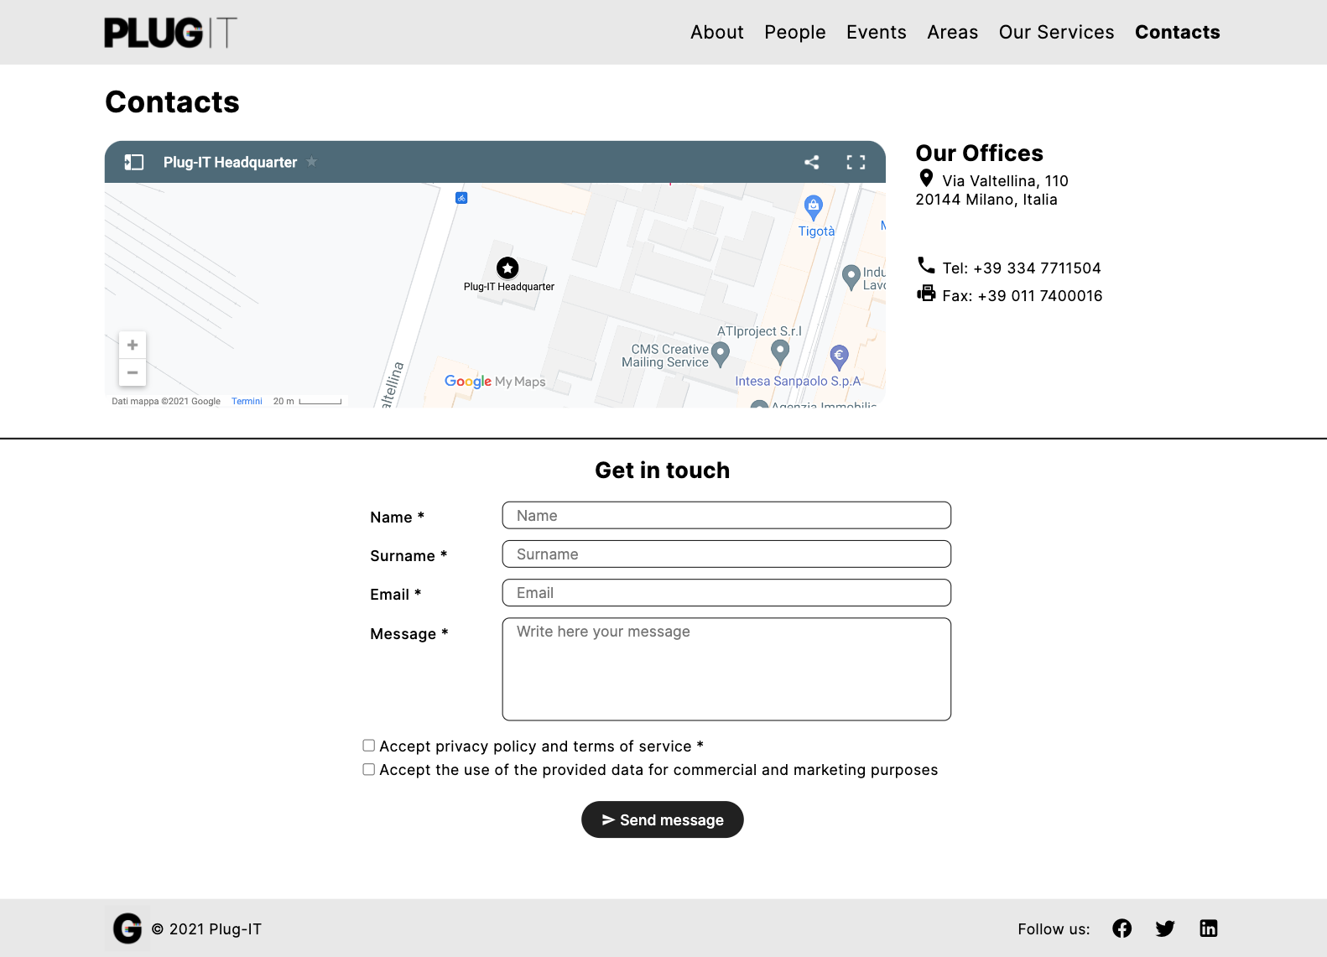

Landmarks

Orientation info

Landmarks

Orientation info

Prototype 3 – Single Topic Page: Contacts Page

* 1. **Introductory Pages**

This chapter presents the design choices related to the *introductory pages*, the places where users understand what a group is about and who its members are.

### People Page

The *people* *introductory page* consists of a short text introducing the team in general. A brief description of the principles that unite its members is also provided in this section.

The core of the page consists of a grid of *group links* to the individual employee pages. Each element of the grid includes a photo of the employee, his full name, and the position he holds at *Plug-IT*. The navigation among the group members is organized according to the *index pattern*.

Landmarks

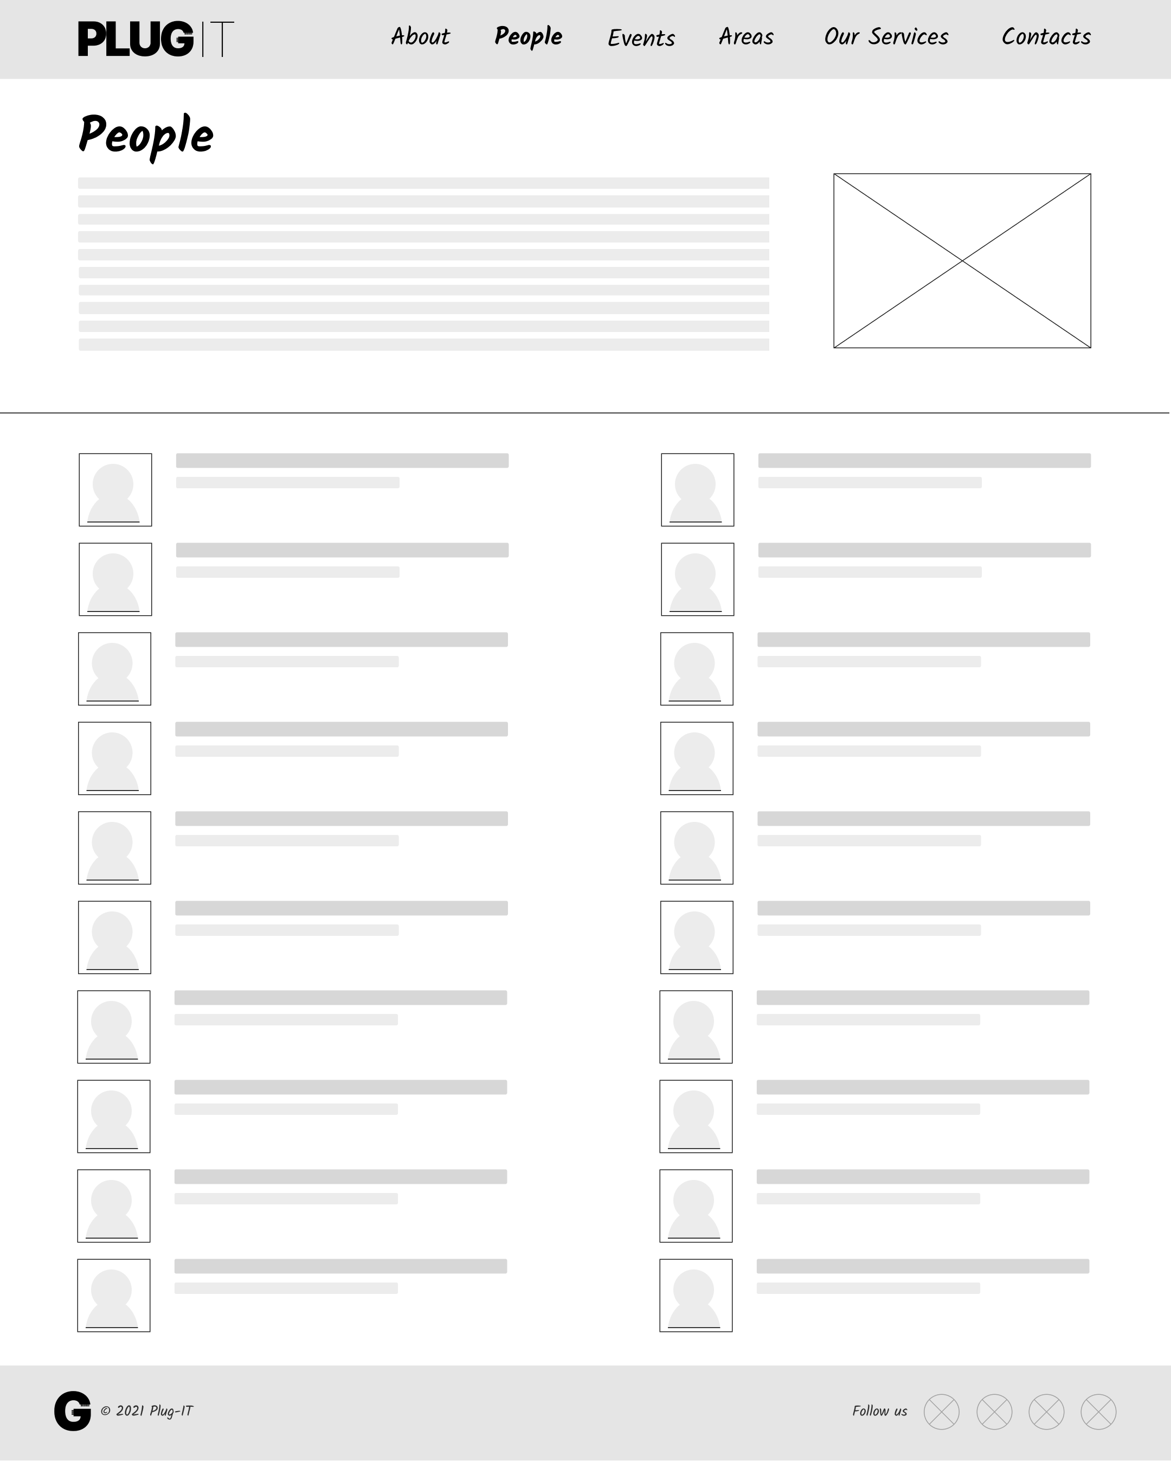

Group links

Landmarks

Orientation info

Orientation info

Wireframe 4 - Introductory Page: People Page

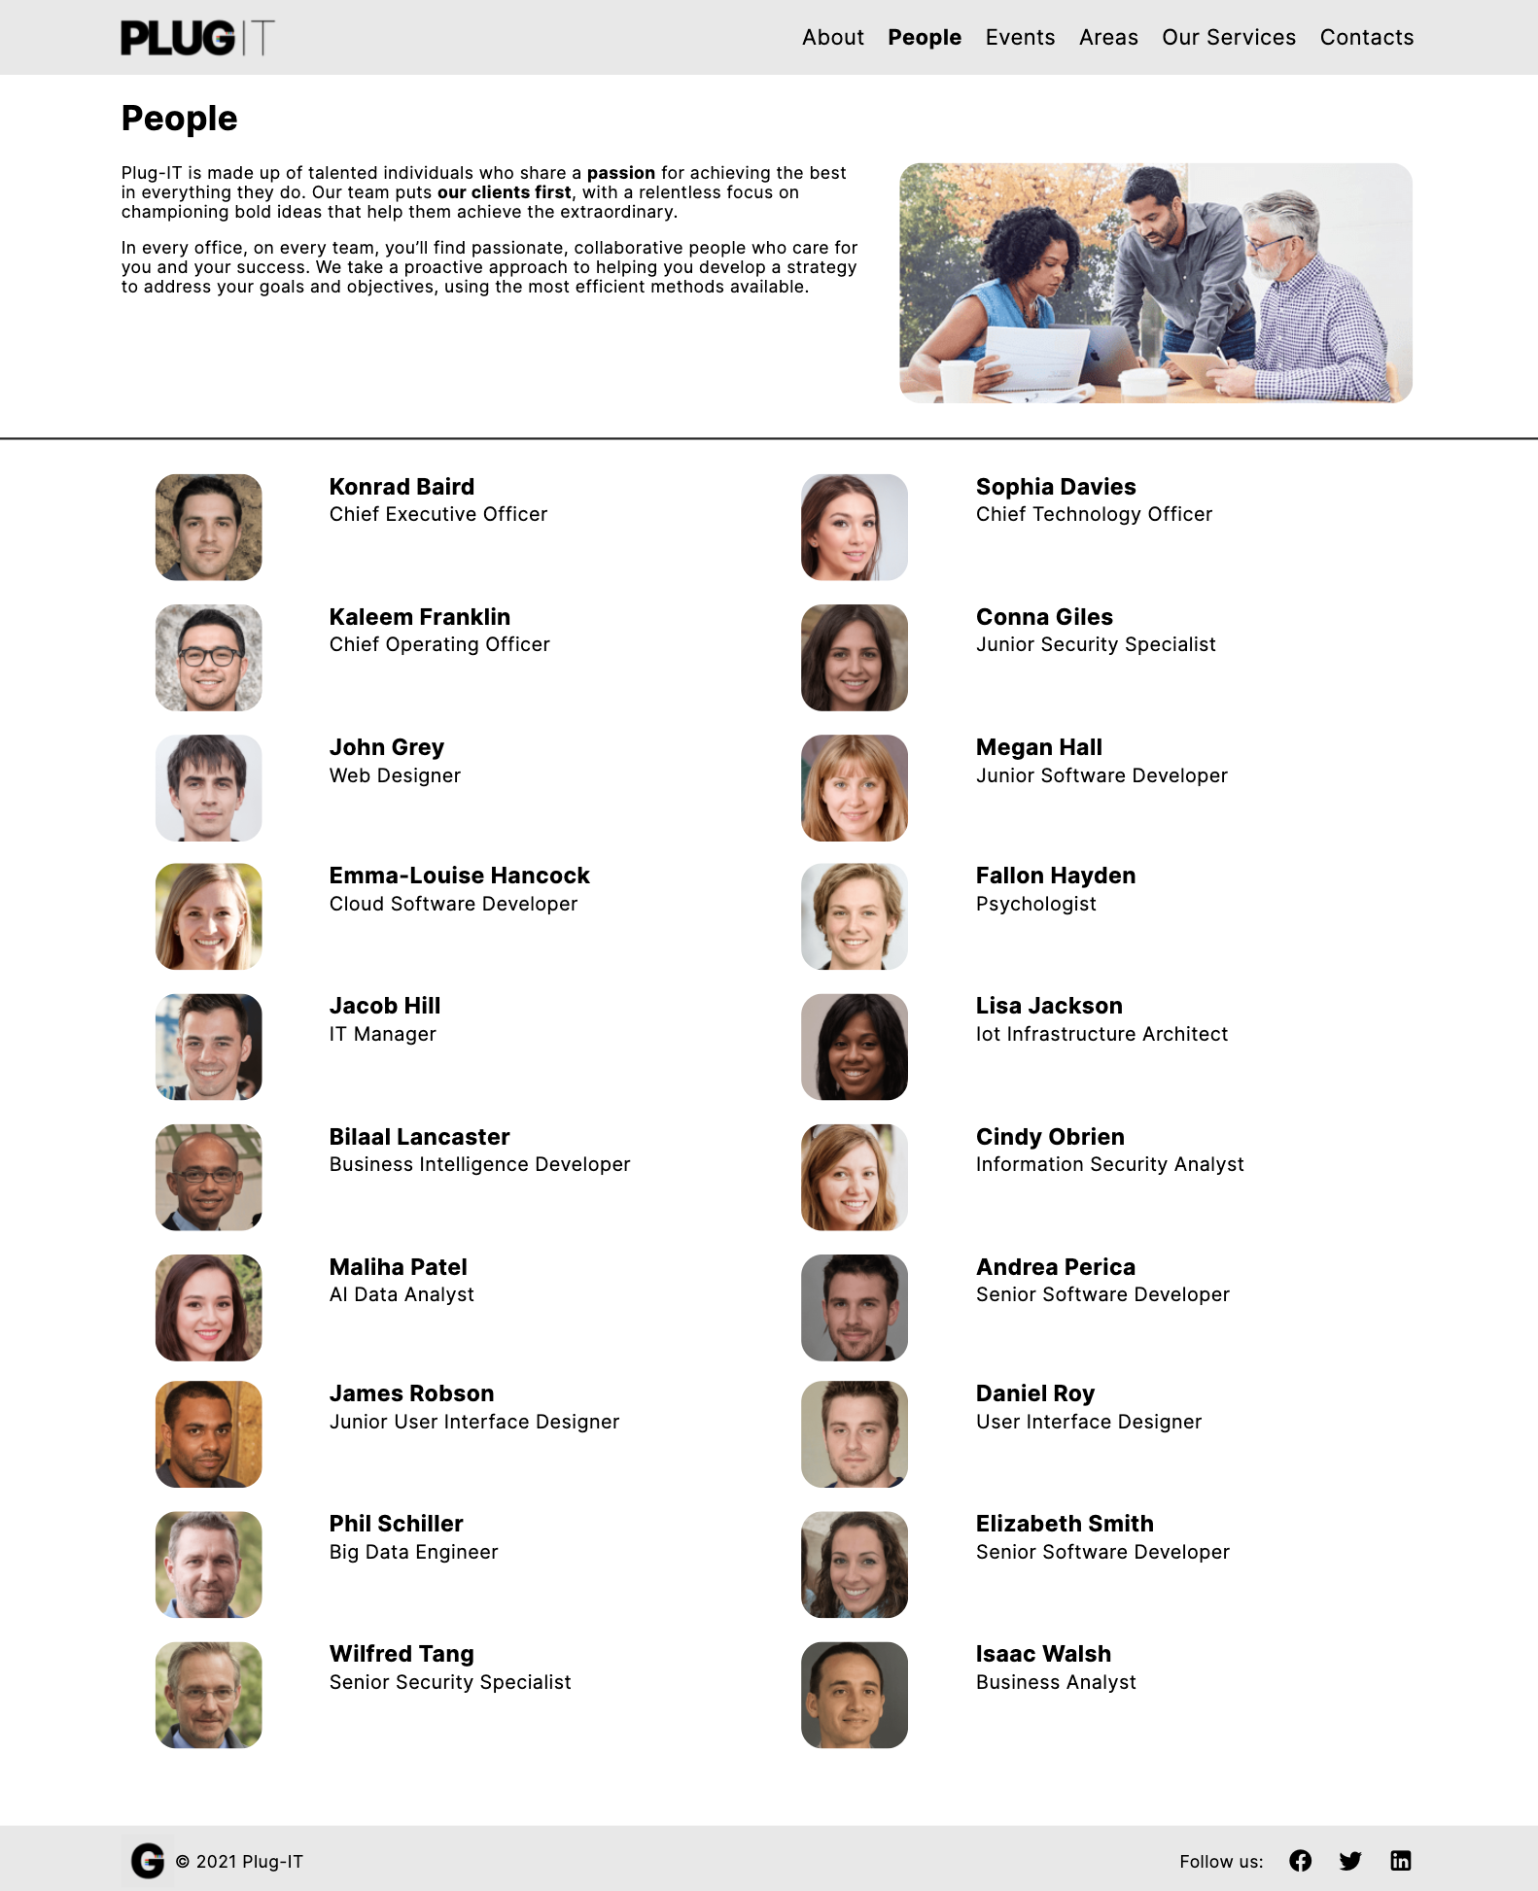

Landmarks

Orientation info

Landmarks

Orientation info

Group links

Prototype 4 - Introductory Page: People Page

### Areas Page

The *areas introductory page* consists of a grid of *group links* to the pages of the individual areas. The navigation between them is organized according to the *index pattern*.

Each element of the grid consists of an illustrative photo, the name of the area and brief description.

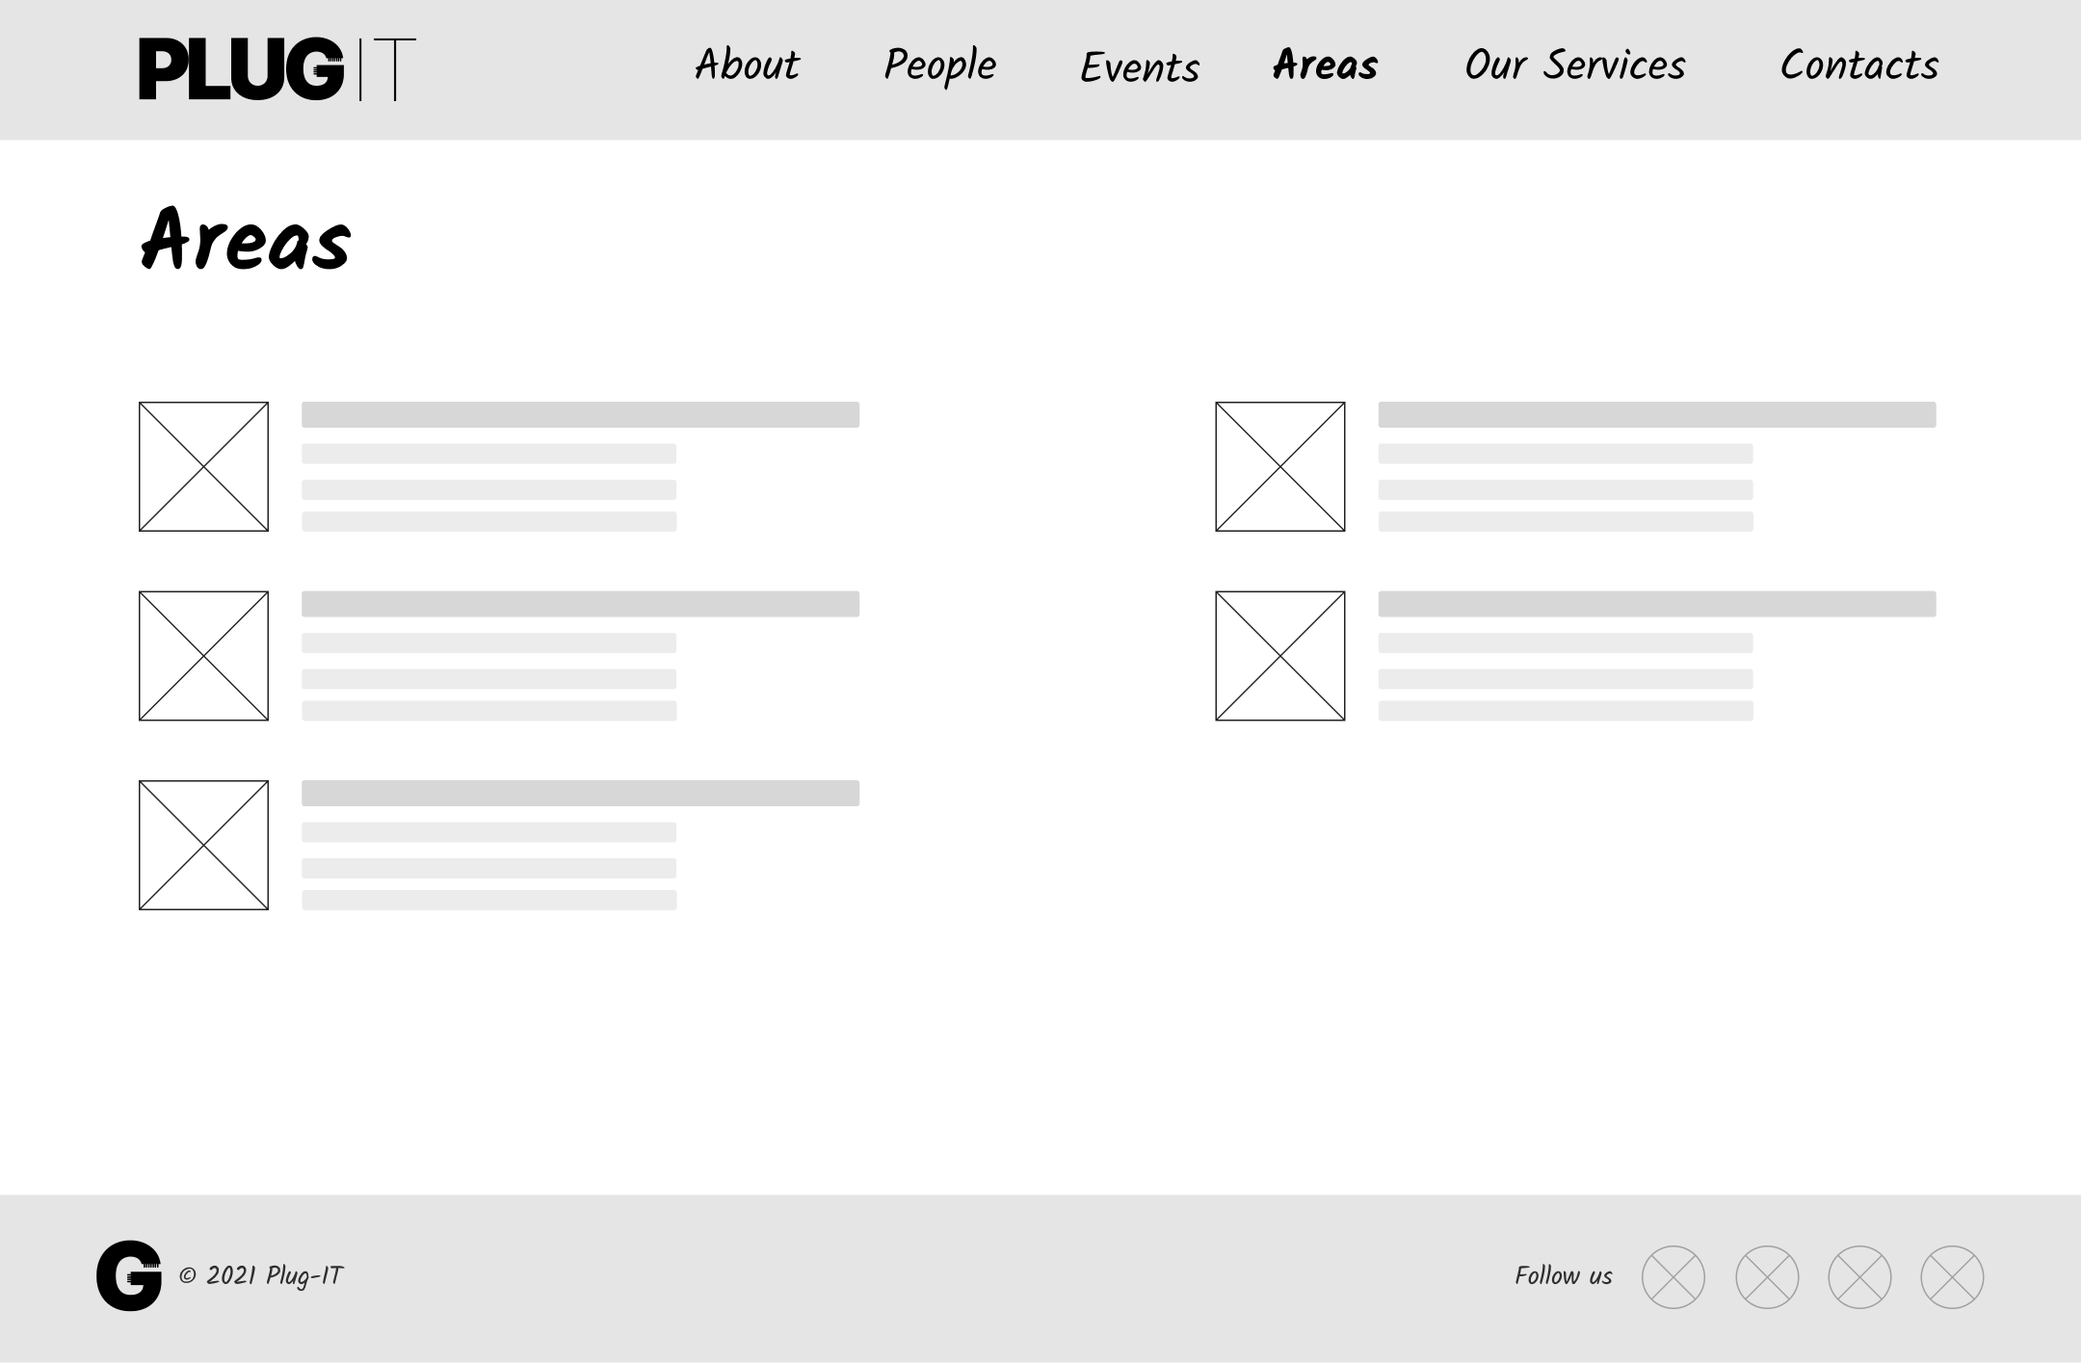

Group links

Landmarks

Orientation info

Orientation info

Landmarks

Wireframe 5 -Introductory Page: Areas Page

Landmarks

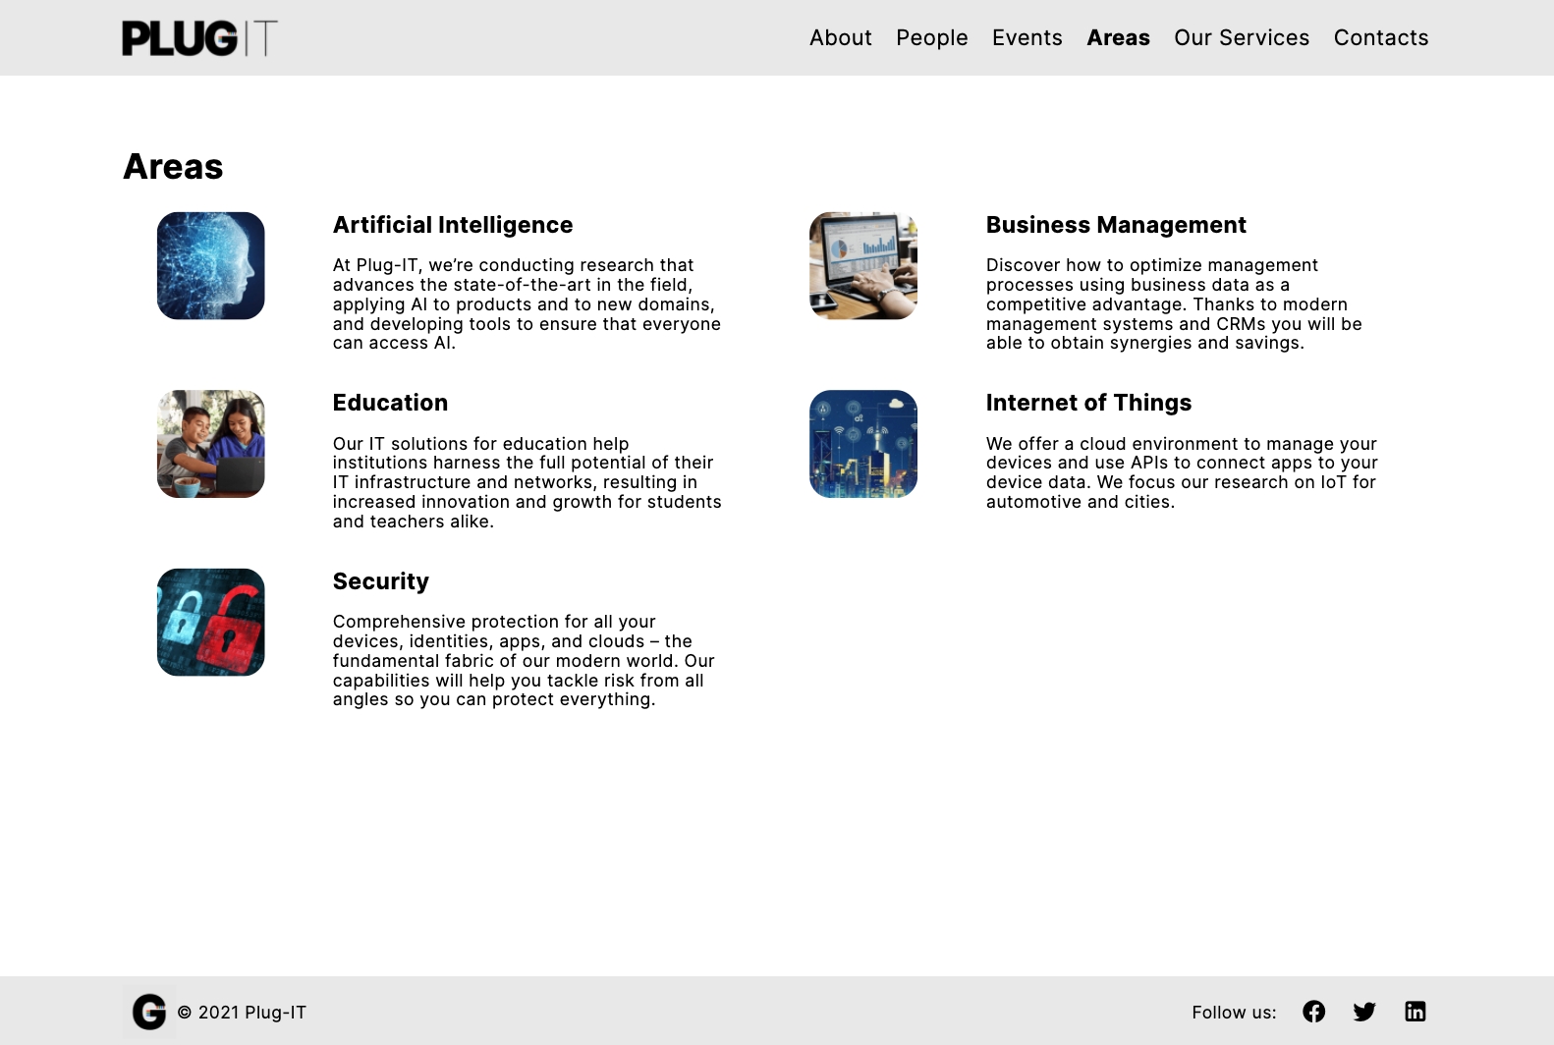

Group links

Landmarks

Orientation info

Orientation info

Landmarks

Prototype 5 - Introductory Page: Areas Page

### Our Services Page

The *Our Services introductory page* consists of a grid of *group links* to the pages of the individual services. As previously defined in the PIDM, the navigation between them is organized according to the *index pattern*. Each element of the grid consists of an illustrative photo, the name of the service and the area to which it belongs. In addition, there is also a very short sentence that allows customers to quickly understand what the service consists of. Finally, a dropdown menu allows users to filter services based on the area of interest.

Landmarks

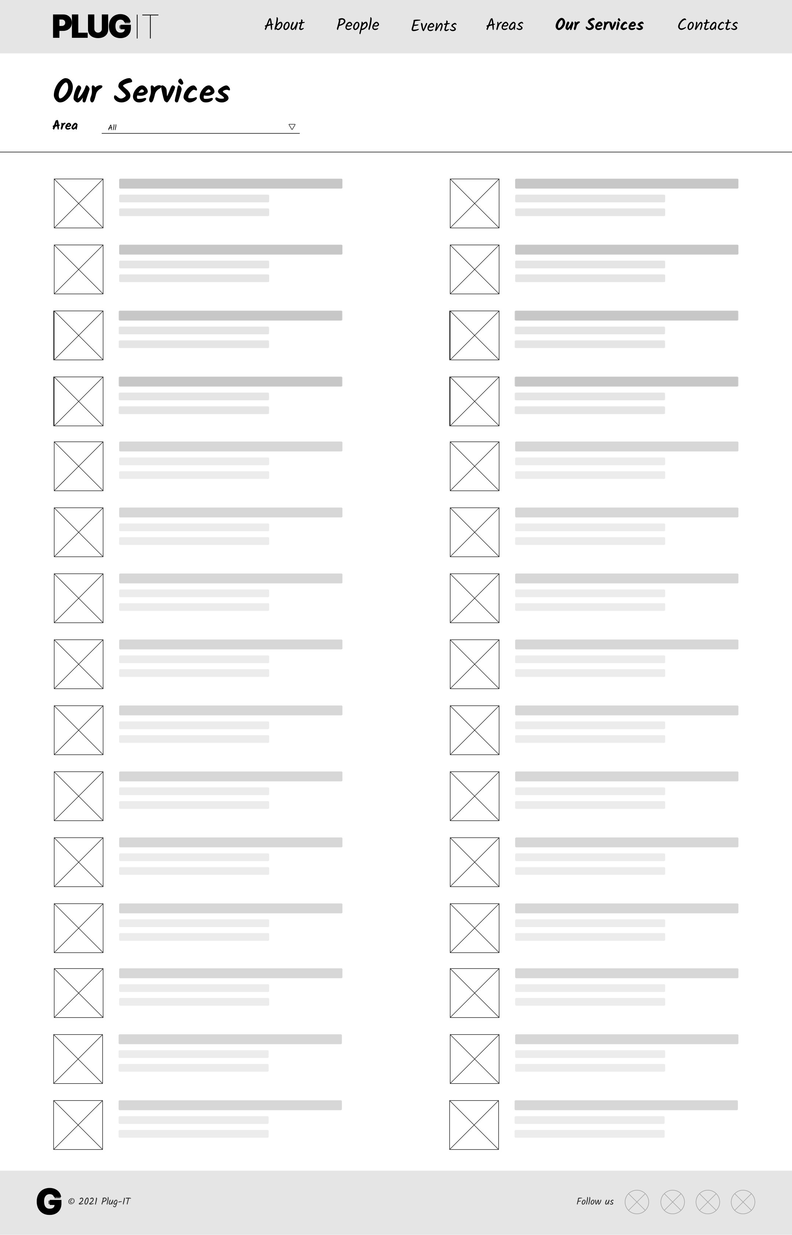

Group link

Orientation info

Landmarks

Group links

Orientation info

Wireframe 6 - Introductory Page: Our Services Page

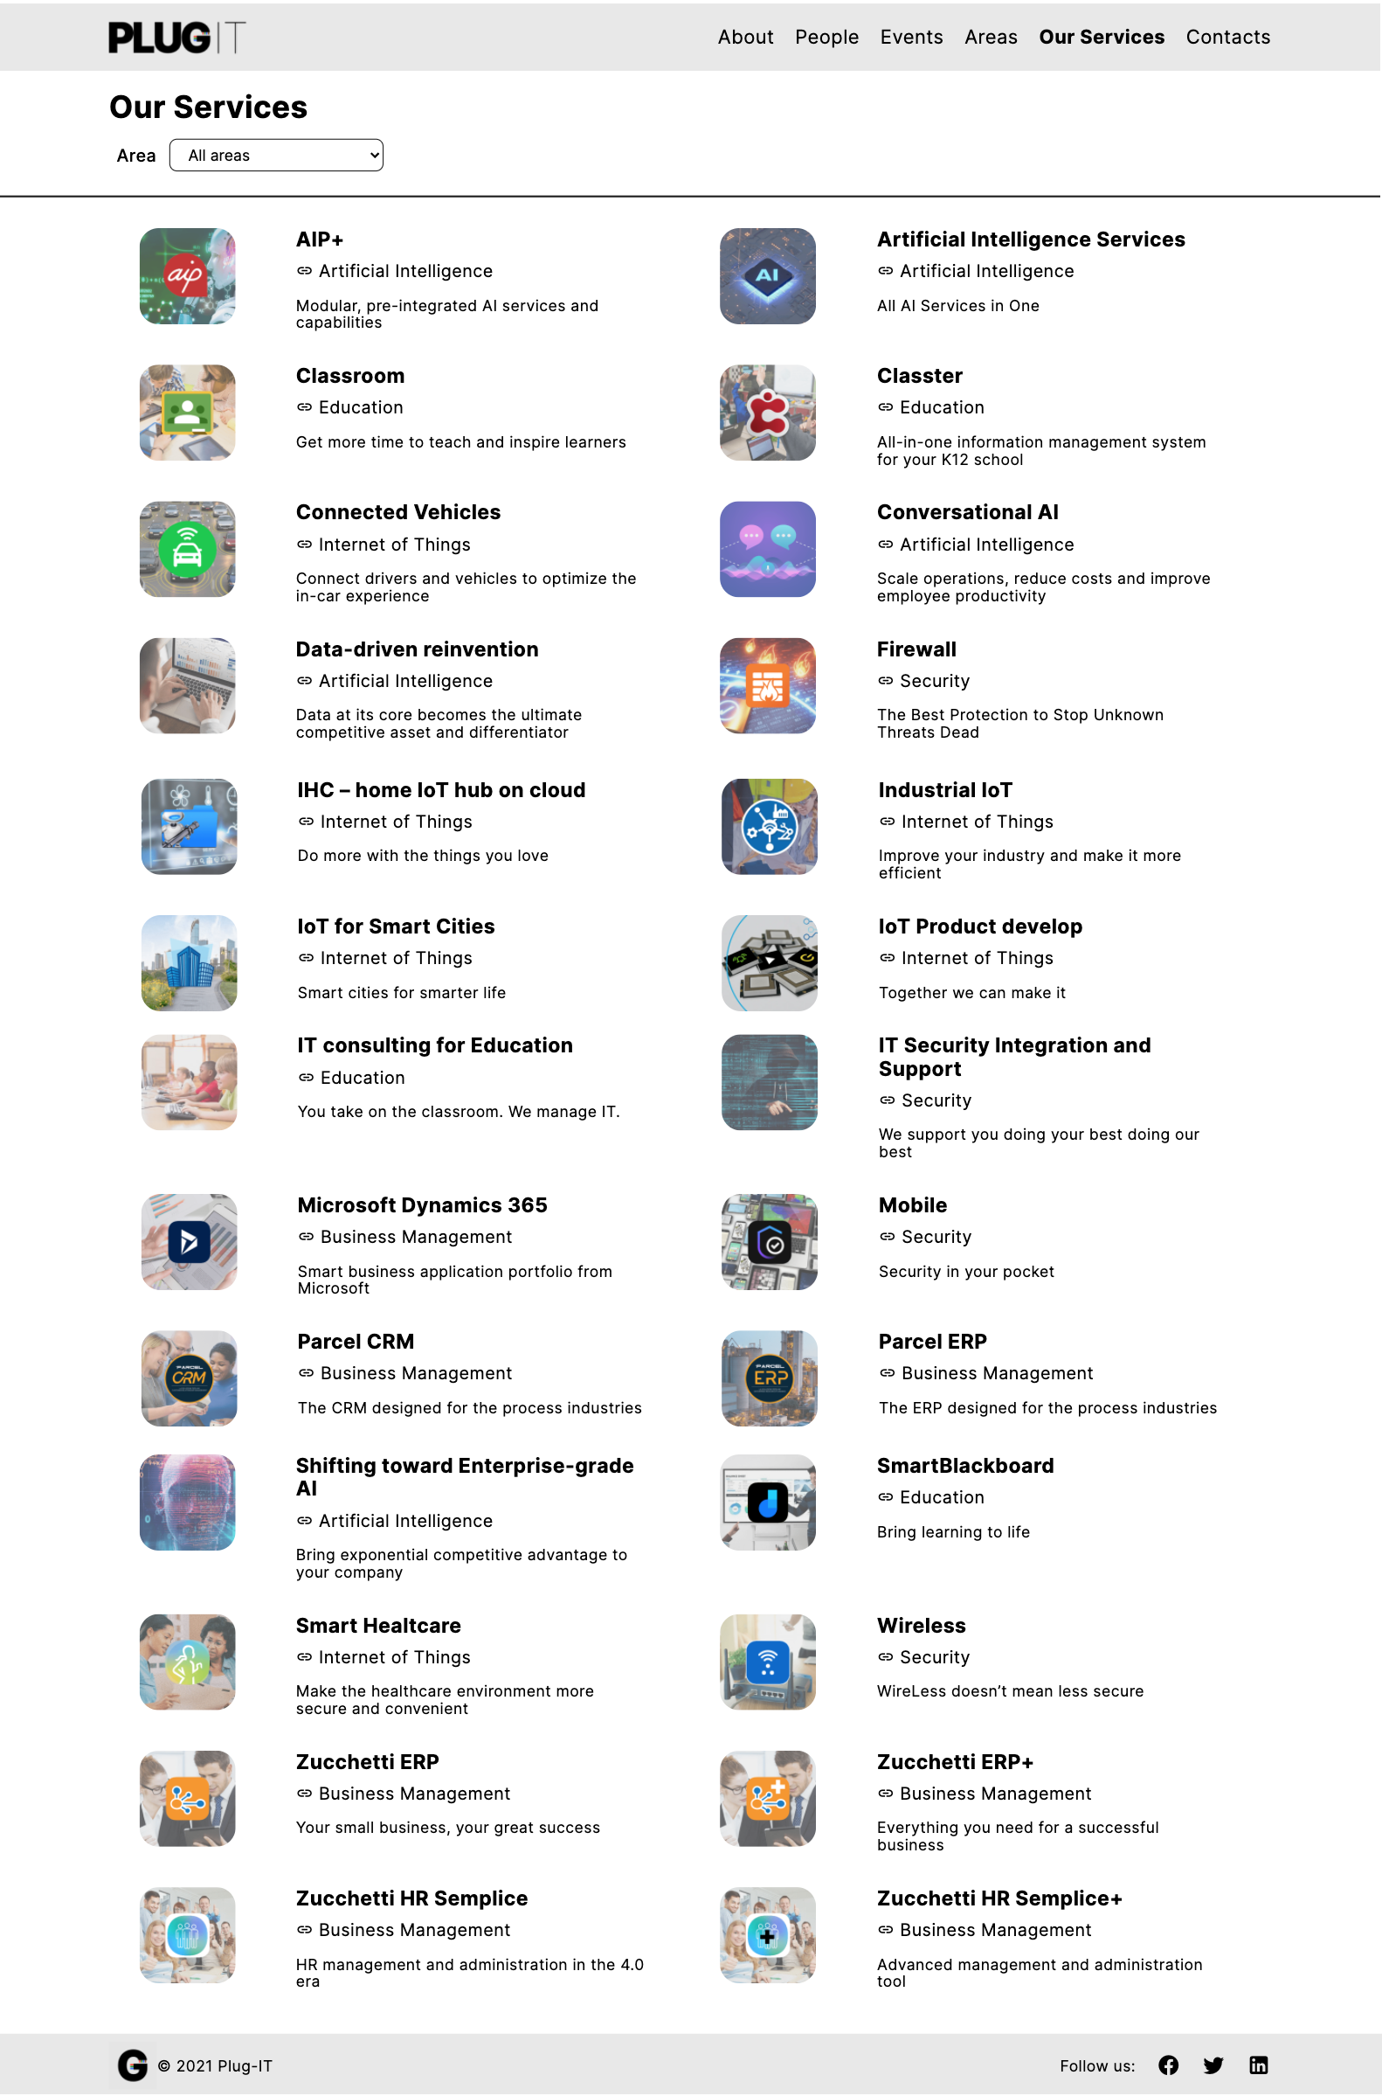

Transition link

Transition link

Transition link

Transition link

Transition link

Transition link

Transition link

Transition link

Transition link

Transition link

Transition link

Transition link

Transition link

Transition link

Transition link

Transition link

Transition link

Transition link

Transition link

Transition link

Transition link

Transition link

Transition link

Transition link

Transition link

Transition link

Landmarks

Group links

Orientation info

Group link

Orientation info

Landmarks

Prototype 6 - Introductory Page: Our Services Page

### Events Page

The *Events introductory page* consists of a grid of *group links* to the pages of the individual events.

Each element of the grid consists of an illustrative photo, the name of the event, the date on which it will be held and the area to which it belongs. In addition, there is also a brief overview that allows customers to quickly understand what it is about.

Finally, a dropdown menu allows users to filter events based on the area they are associated with.

In any case, the navigation between the pages of the individual events is organized according to the *index pattern*.

Landmarks

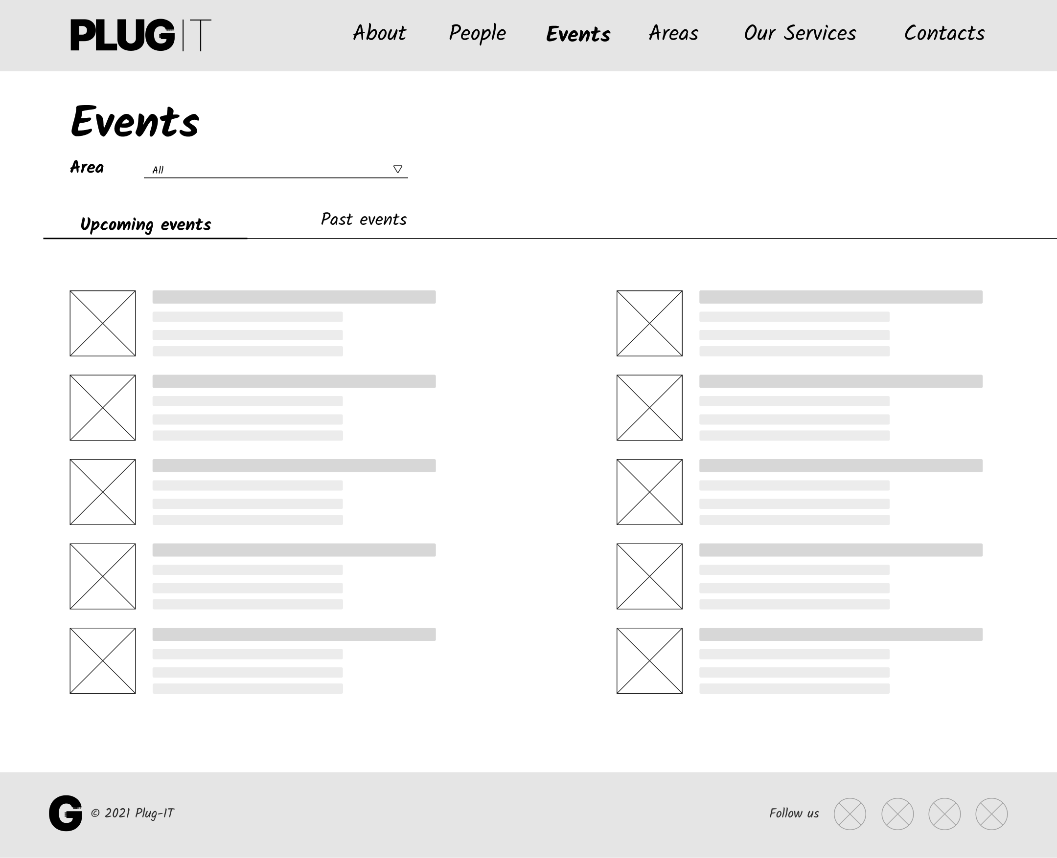

Landmarks

Group links

Group link

Orientation info

Group link

Orientation info

Wireframe 7 - Introductory Page: Events Page

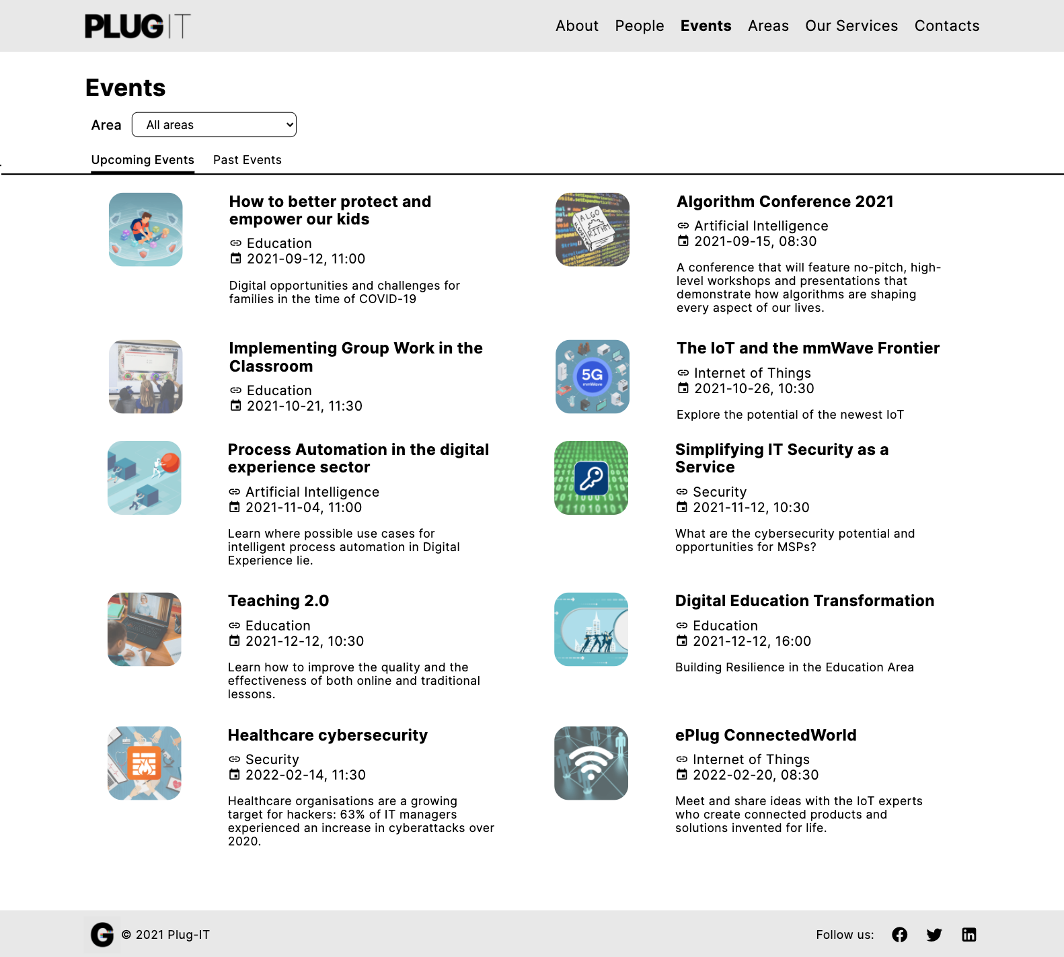

Transition link

Transition link

Transition link

Transition link

Transition link

Transition link

Transition link

Transition link

Group link

Landmarks

Landmarks

Group links

Transition link

Transition link

Orientation info

Group link

Orientation info

Prototype 7 - Introductory Page: Events Page

* 1. **Multiple Topic Pages**

This section describes the design choices relating to the *multiple topic pages*, the places where users consume contents about topics of a given kind.

### Person Page

The *Person page* is intended to provide information relating to an individual *Plug-IT* employee.

The full name of the worker and the position held within the company are provided below the breadcrumb. At the top of the page, it is shown a photo of the employee and his biography.

In the lower part, instead, all the activities in which the person is involved are listed. In particular, if the worker is responsible for an area, a “Responsibilities” section is shown containing a *transition link* to the related area page.

All the *transition links* to the services in which the person works are then shown in a grid view. For each of them is displayed an illustrative picture, the name of the service and its slogan. In addition, for each service, is reported the area to which it belongs. The latter represents a *transition link* to the dedicated page.

Landmarks

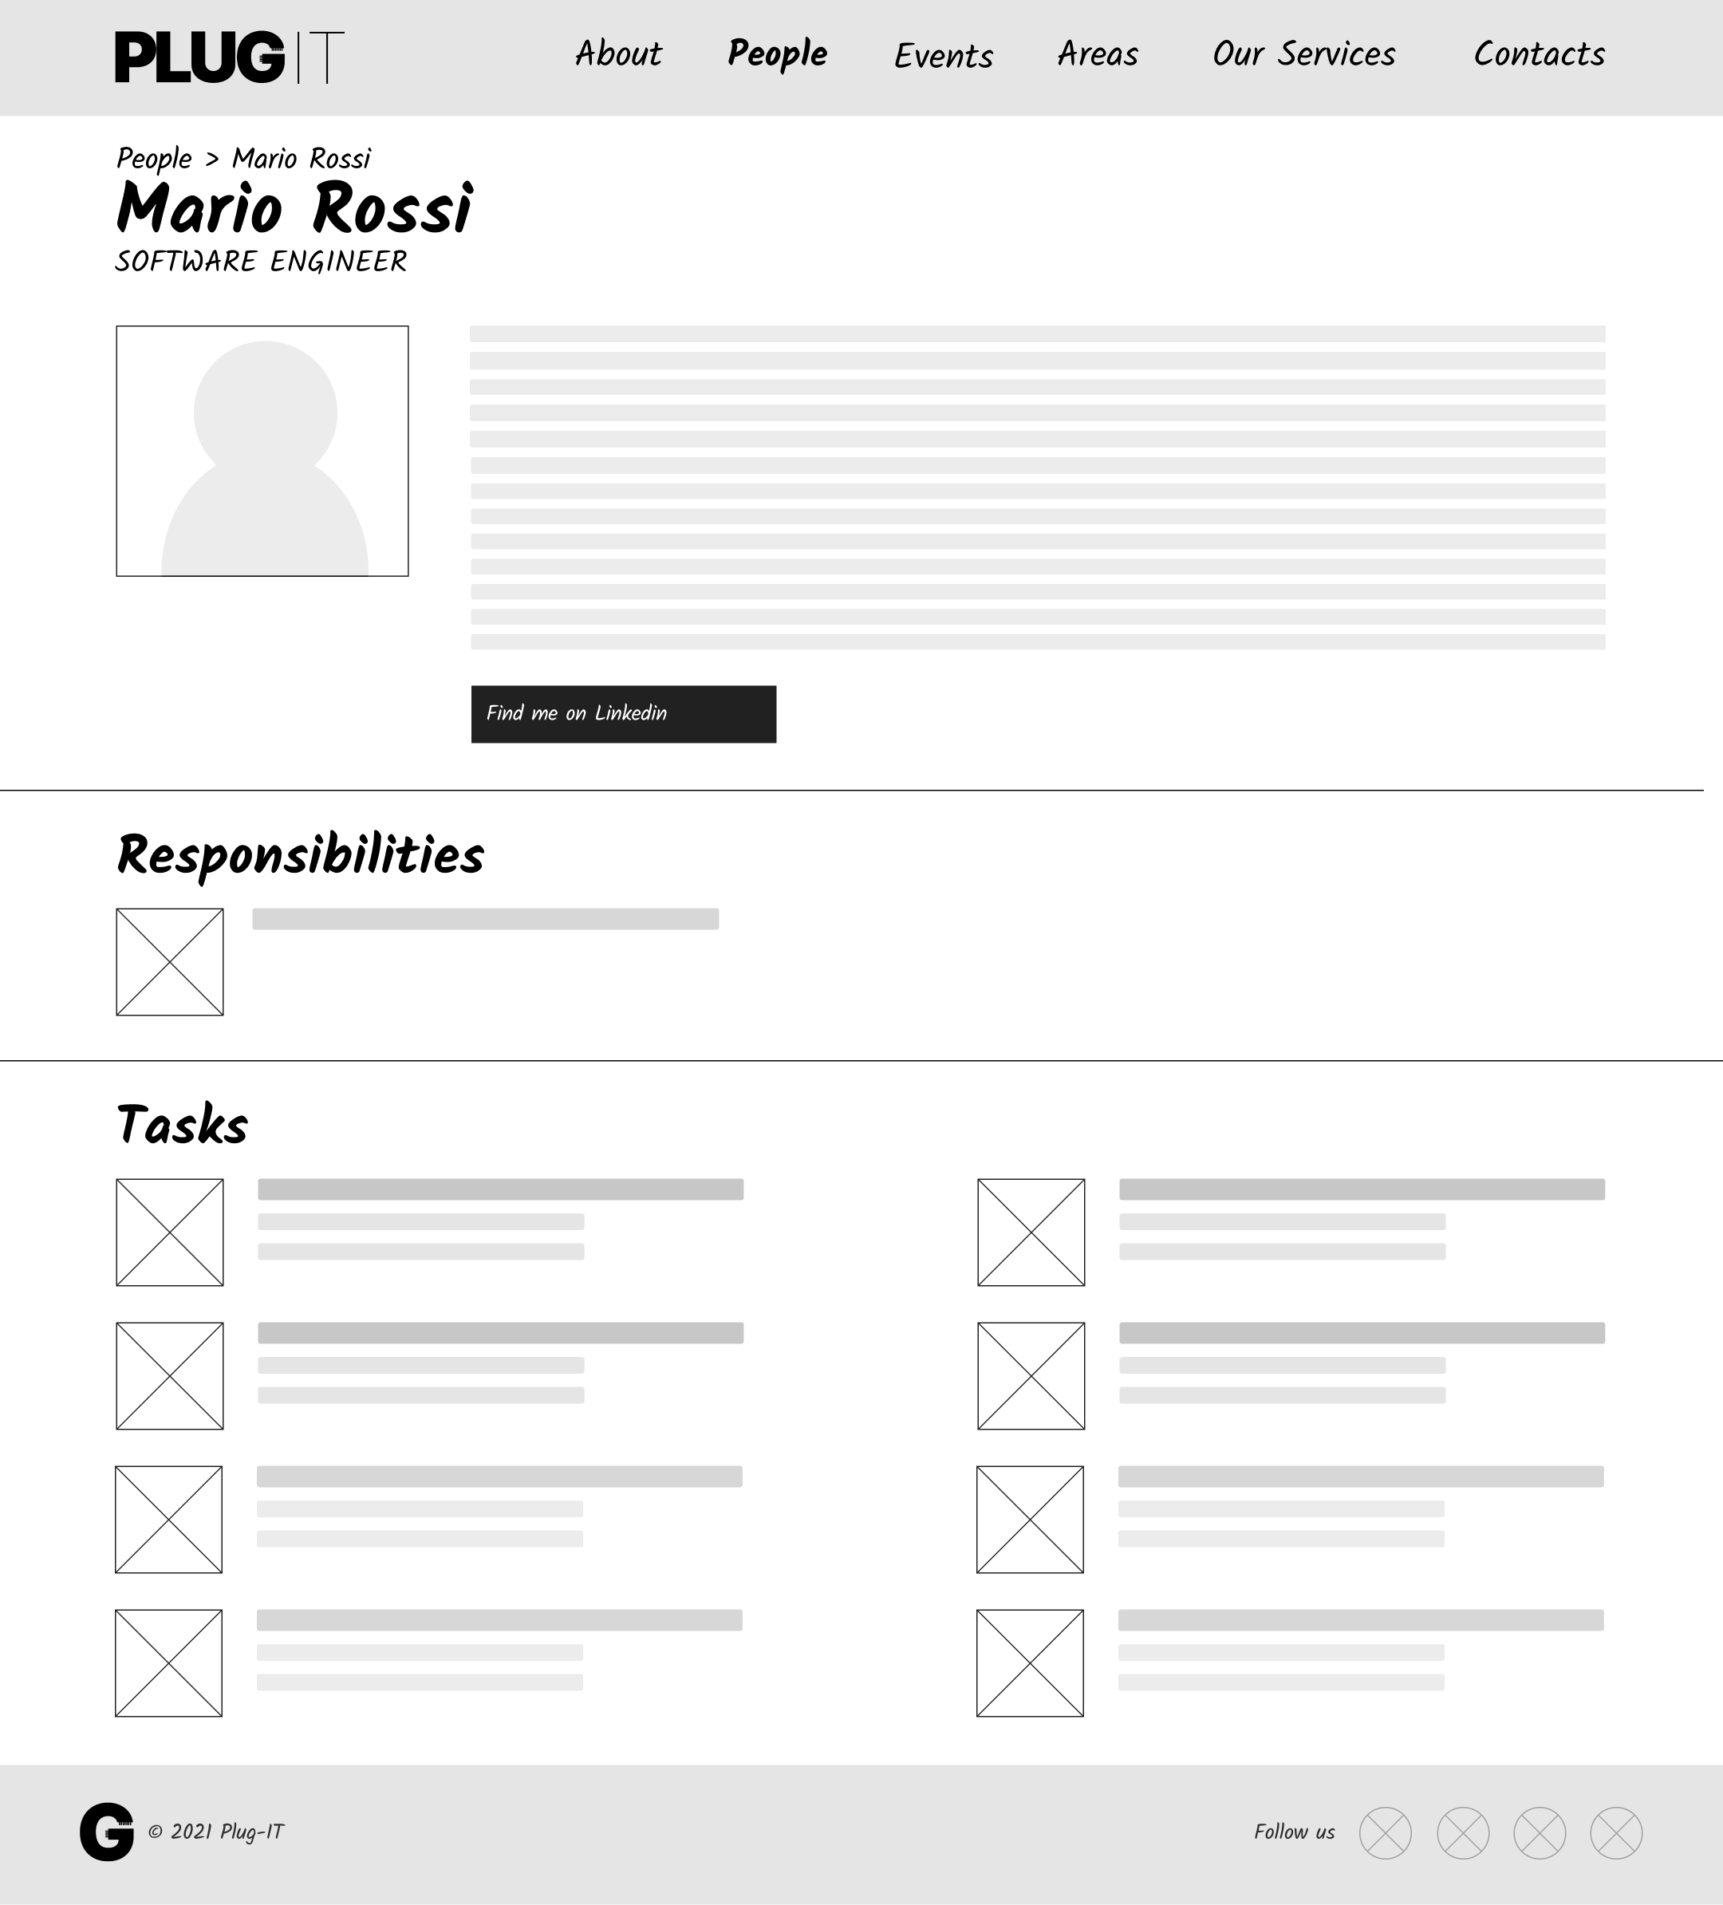

Orientation info

Landmarks

Transition links

Transition link

Group link

Orientation info

Wireframe 8 - Multiple Topic Page: Person Page

Landmarks

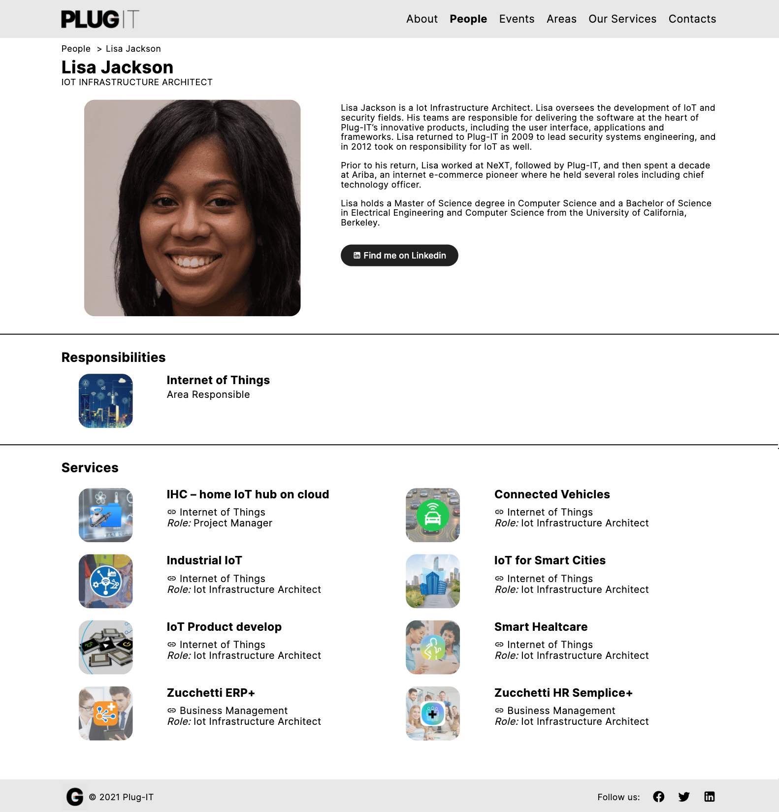

Orientation info

Group link

Landmarks

Transition links

Transition link

Orientation info

Prototype 8 - Multiple Topic Page: Person Page

### Area Page

The *Area page* represents the space in which the user is informed about a specific field in which the company operates. For this page, the goal is to explain what the challenges and objectives in this sector are.

The core of the page consists of a sequence of sections in which all the details relating to the area are explained. For each paragraph, there are also some illustrative images.

Below, there is a button to reach the *transition page* relating to the team working in that specific area (*Area Team Page*).

Finally, in the lower part of the page, all the area’s services offered by *Plug-IT* are listed. For each of them, an illustrative image, the name of the service and its slogan are displayed. This content is organized in a grid view of *transition links*.

Landmarks

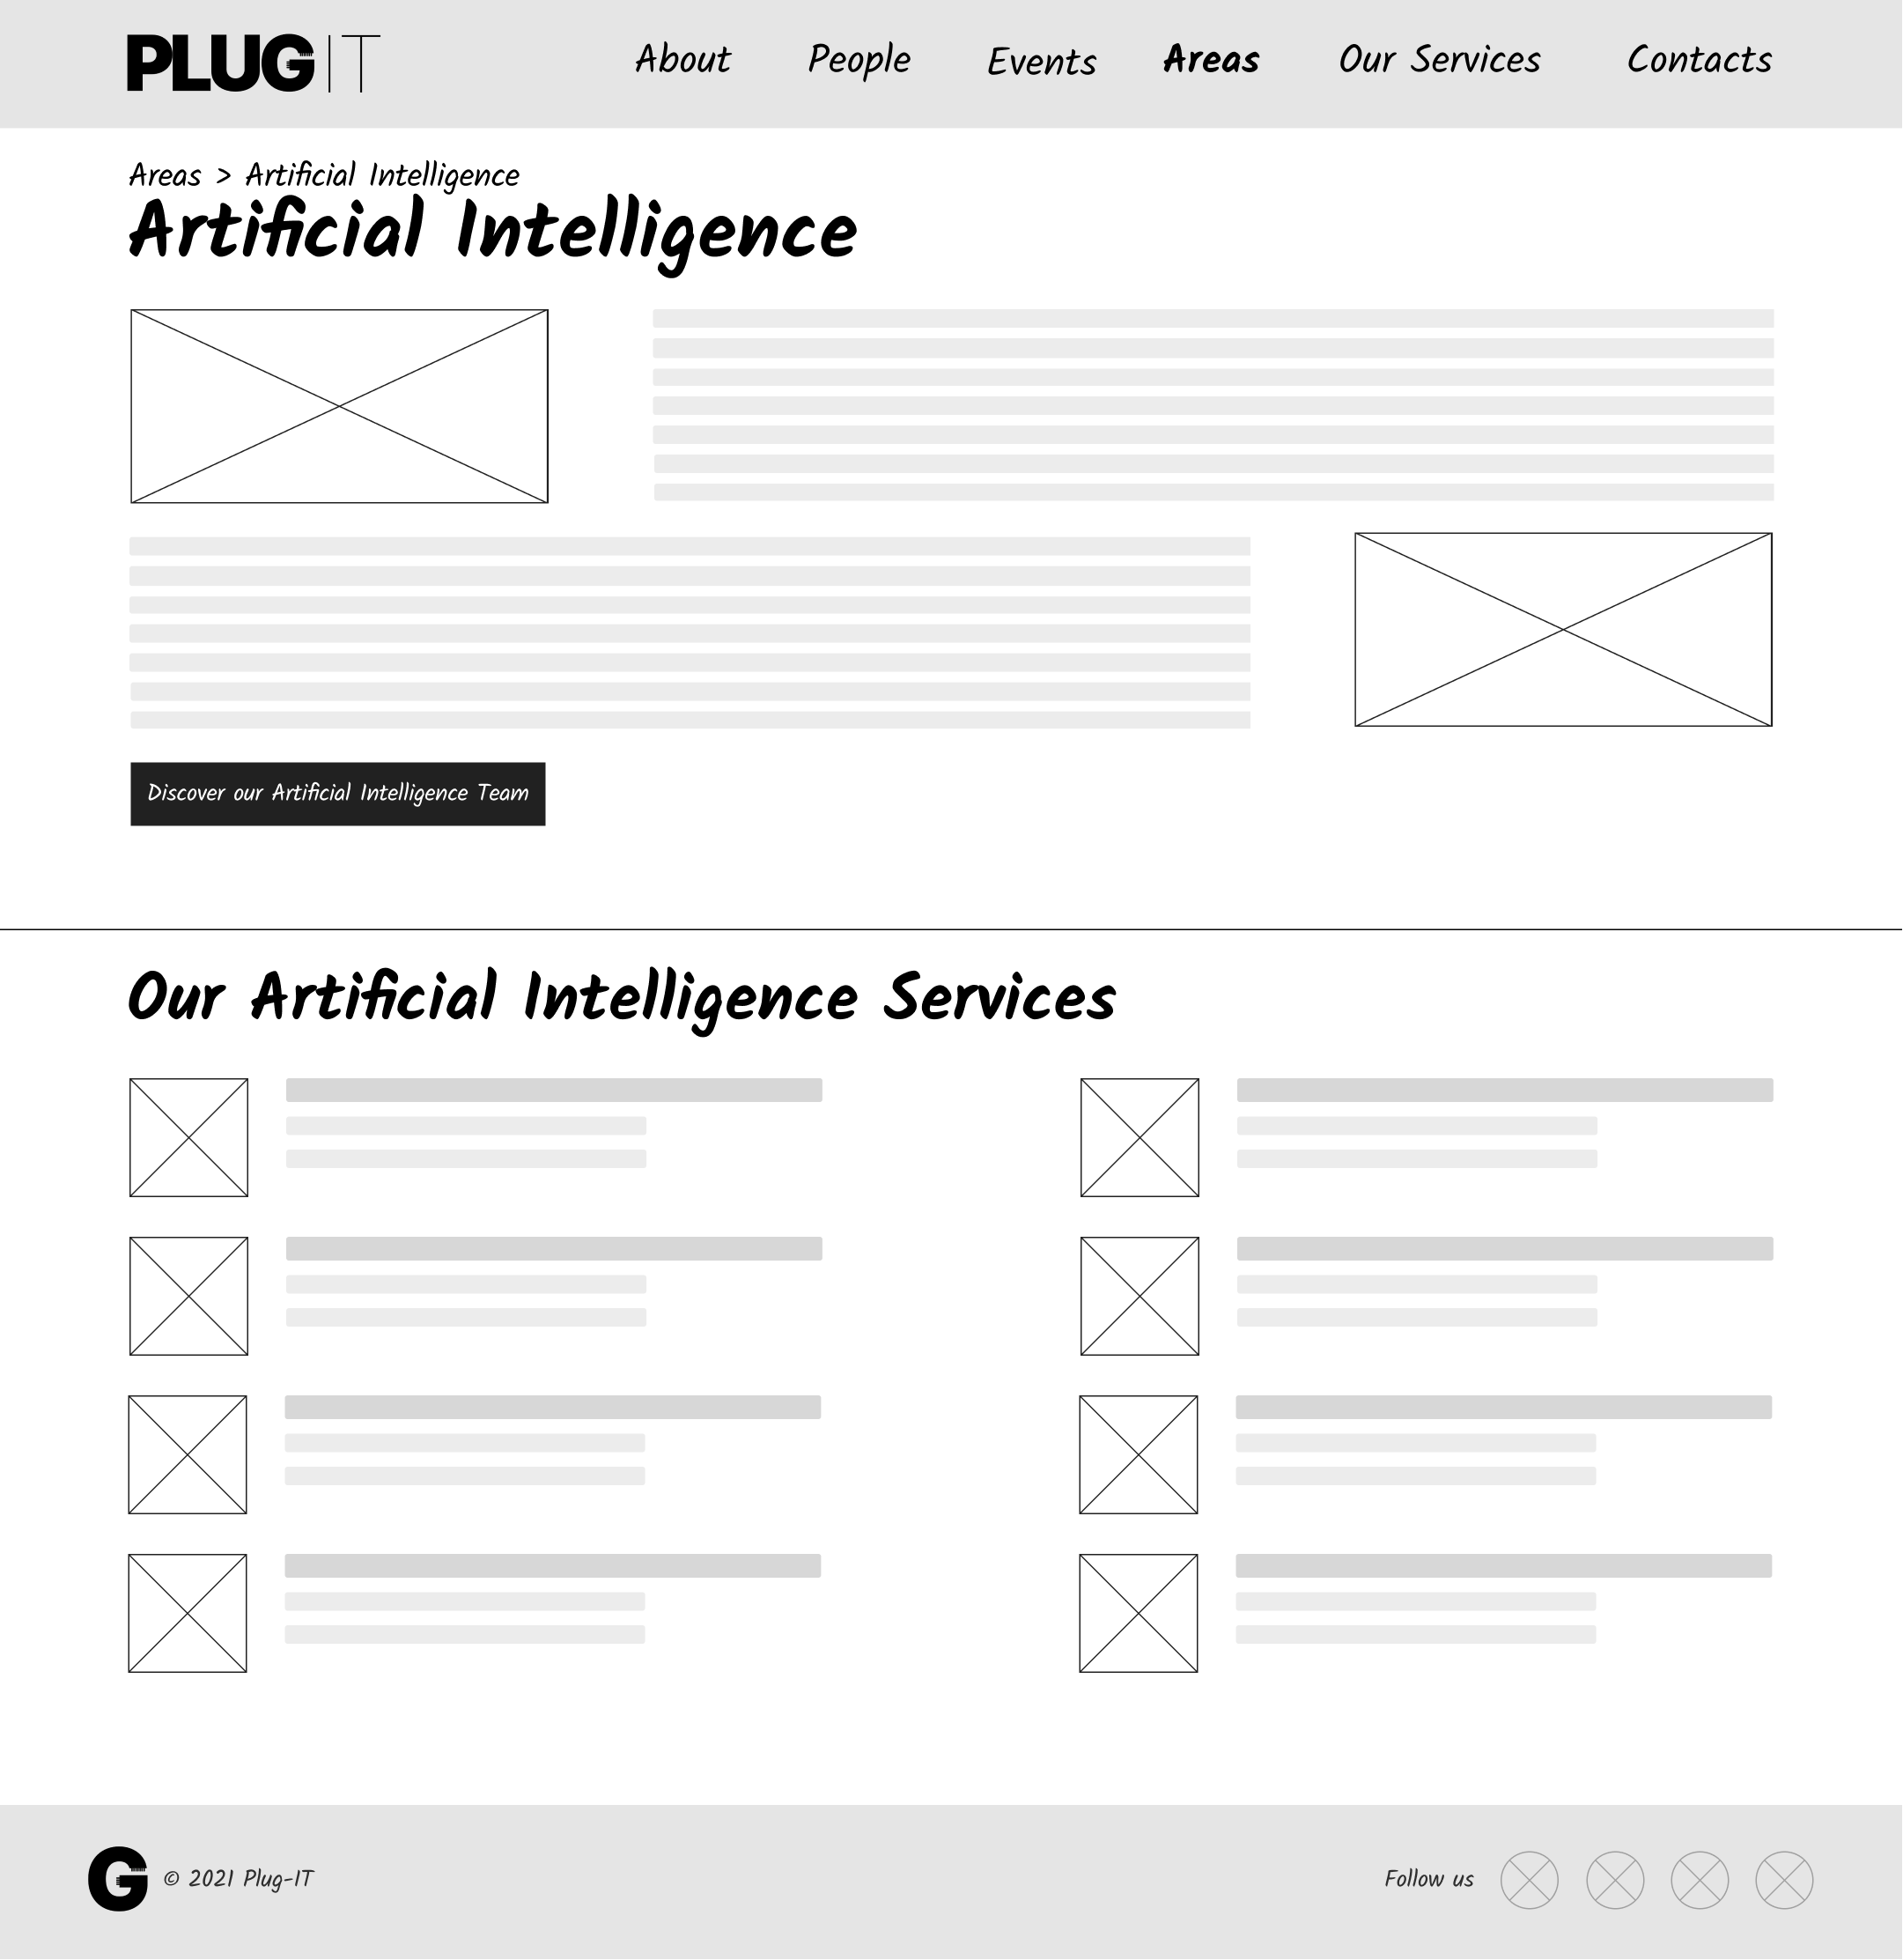

Orientation info

Landmarks

Transition links

Transition link

Group link

Orientation info

Wireframe 9 - Multiple Topic Page: Area Page

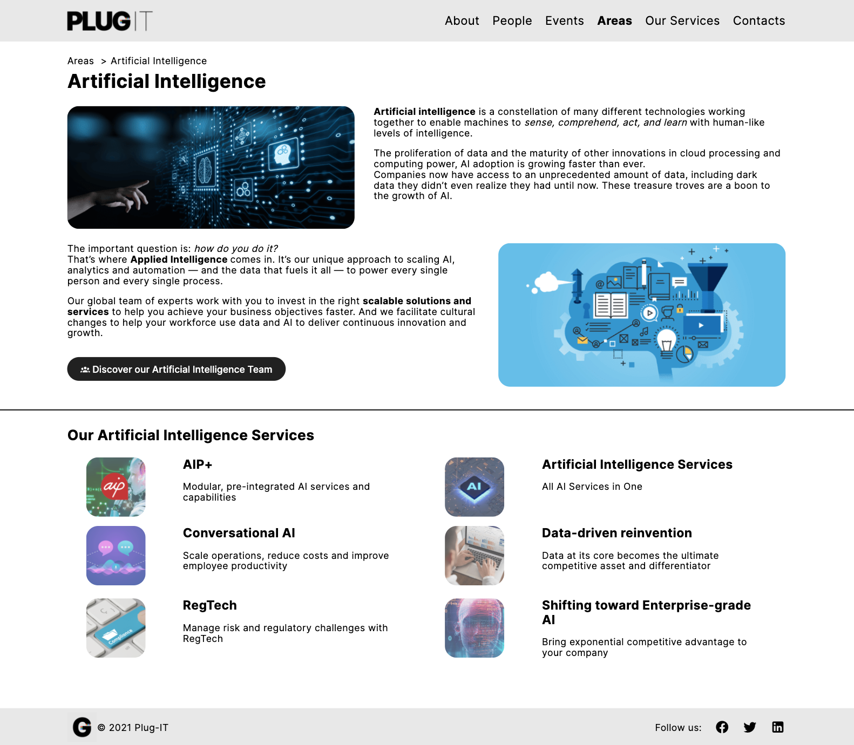

Orientation info

Group link

Landmarks

Transition link

Transition links

Orientation info

Landmarks

Prototype 9 - Multiple Topic Page: Area Page

### Service Page

The *Service page* has the goal of presenting in detail the solution offered by *Plug-IT* to deal with a problem or a need. Below the *breadcrumb*, the service’s name and a *transition link* to the related area page are shown.

The core of the page consists of a sequence of paragraphs in which all the details relating to the service and its characteristics are explained. For each paragraph, some illustrative images are also displayed. Below this section, it is shown a button to reach the *transition page* related to the team working on the service (*Service Team Page*).

Finally, at the bottom of the page, there is a form to contact the company and get even more information about the service.

Landmarks

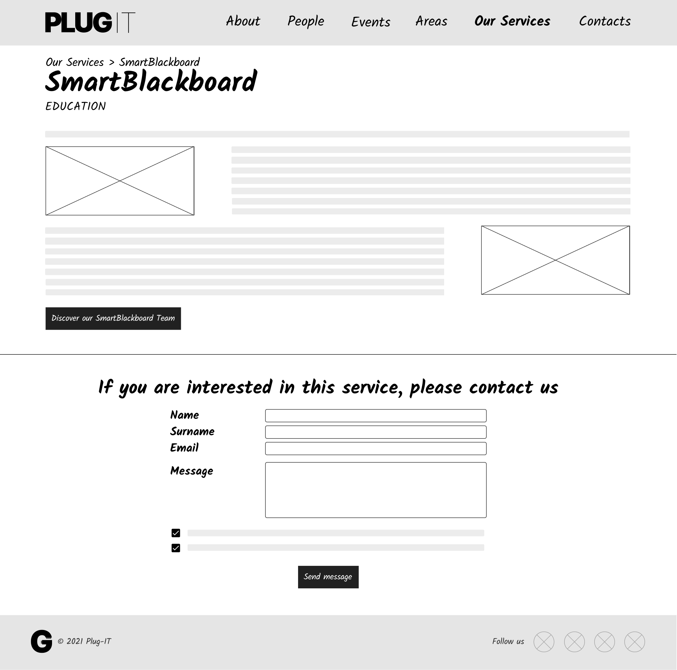

Landmarks

Group link

Orientation info

Transition link

Transition link

Orientation info

Wireframe 10 - Multiple Topic Page: Service Page

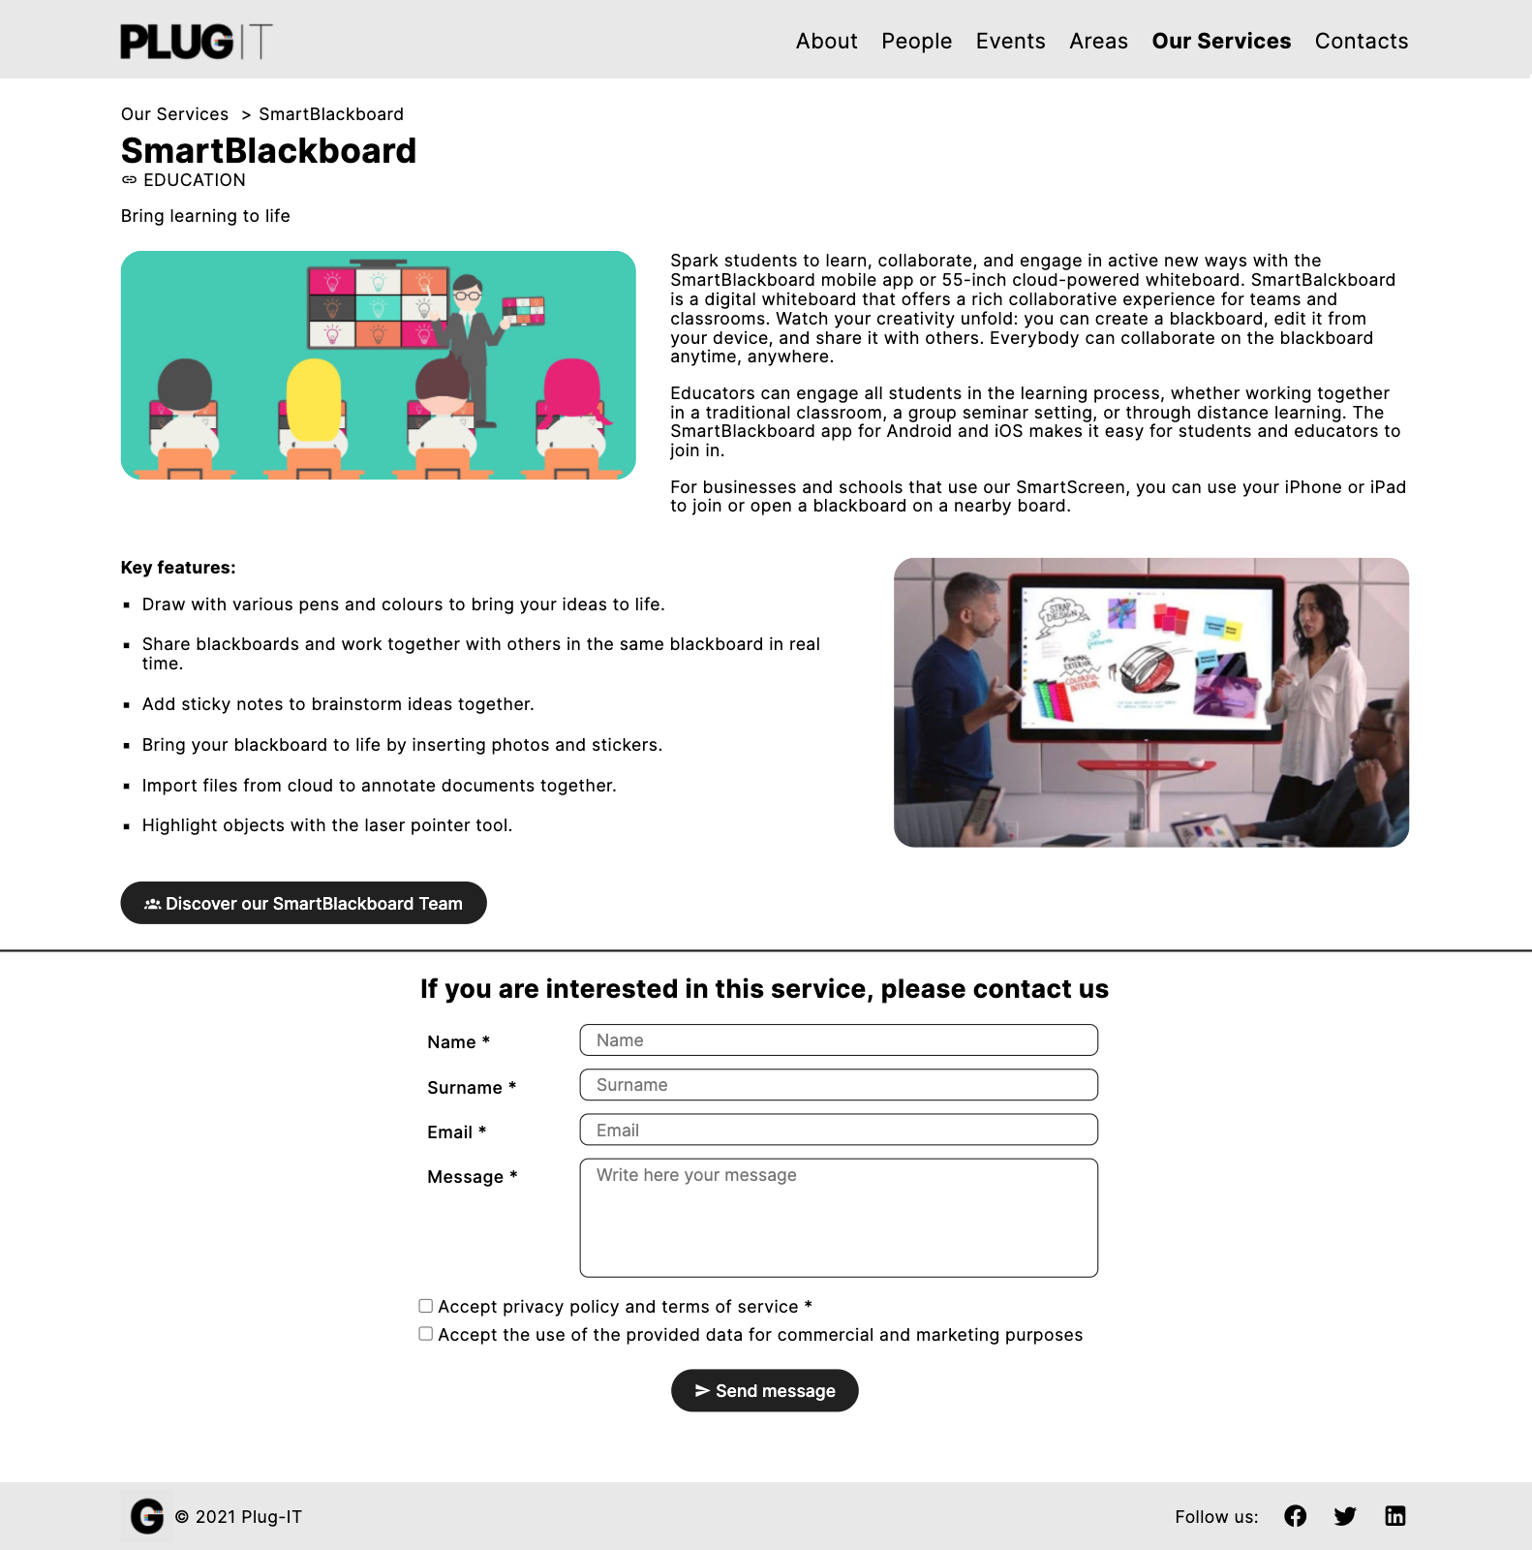

Landmarks

Transition link

Orientation info

Transition link

Orientation info

Group link

Landmarks

Prototype 10 - Multiple Topic Page: Service Page

### Event Page

The *Event page* shows all the details related to a specific event.

Below the breadcrumb, it is shown the name of the event and a *transition link* to the page of the area to which it is associated. Then, it follows a description of the event and the covered topics. Furthermore, it is displayed a set of *transition links* to the personal profiles of the hosts who will take part in the event.

Finally, the page shows an interactive map explaining where the event will be held with the full address of the location. The start date and time are also reported alongside.

At the bottom of the page, there is a contact form to get even more information about the event.

Landmarks

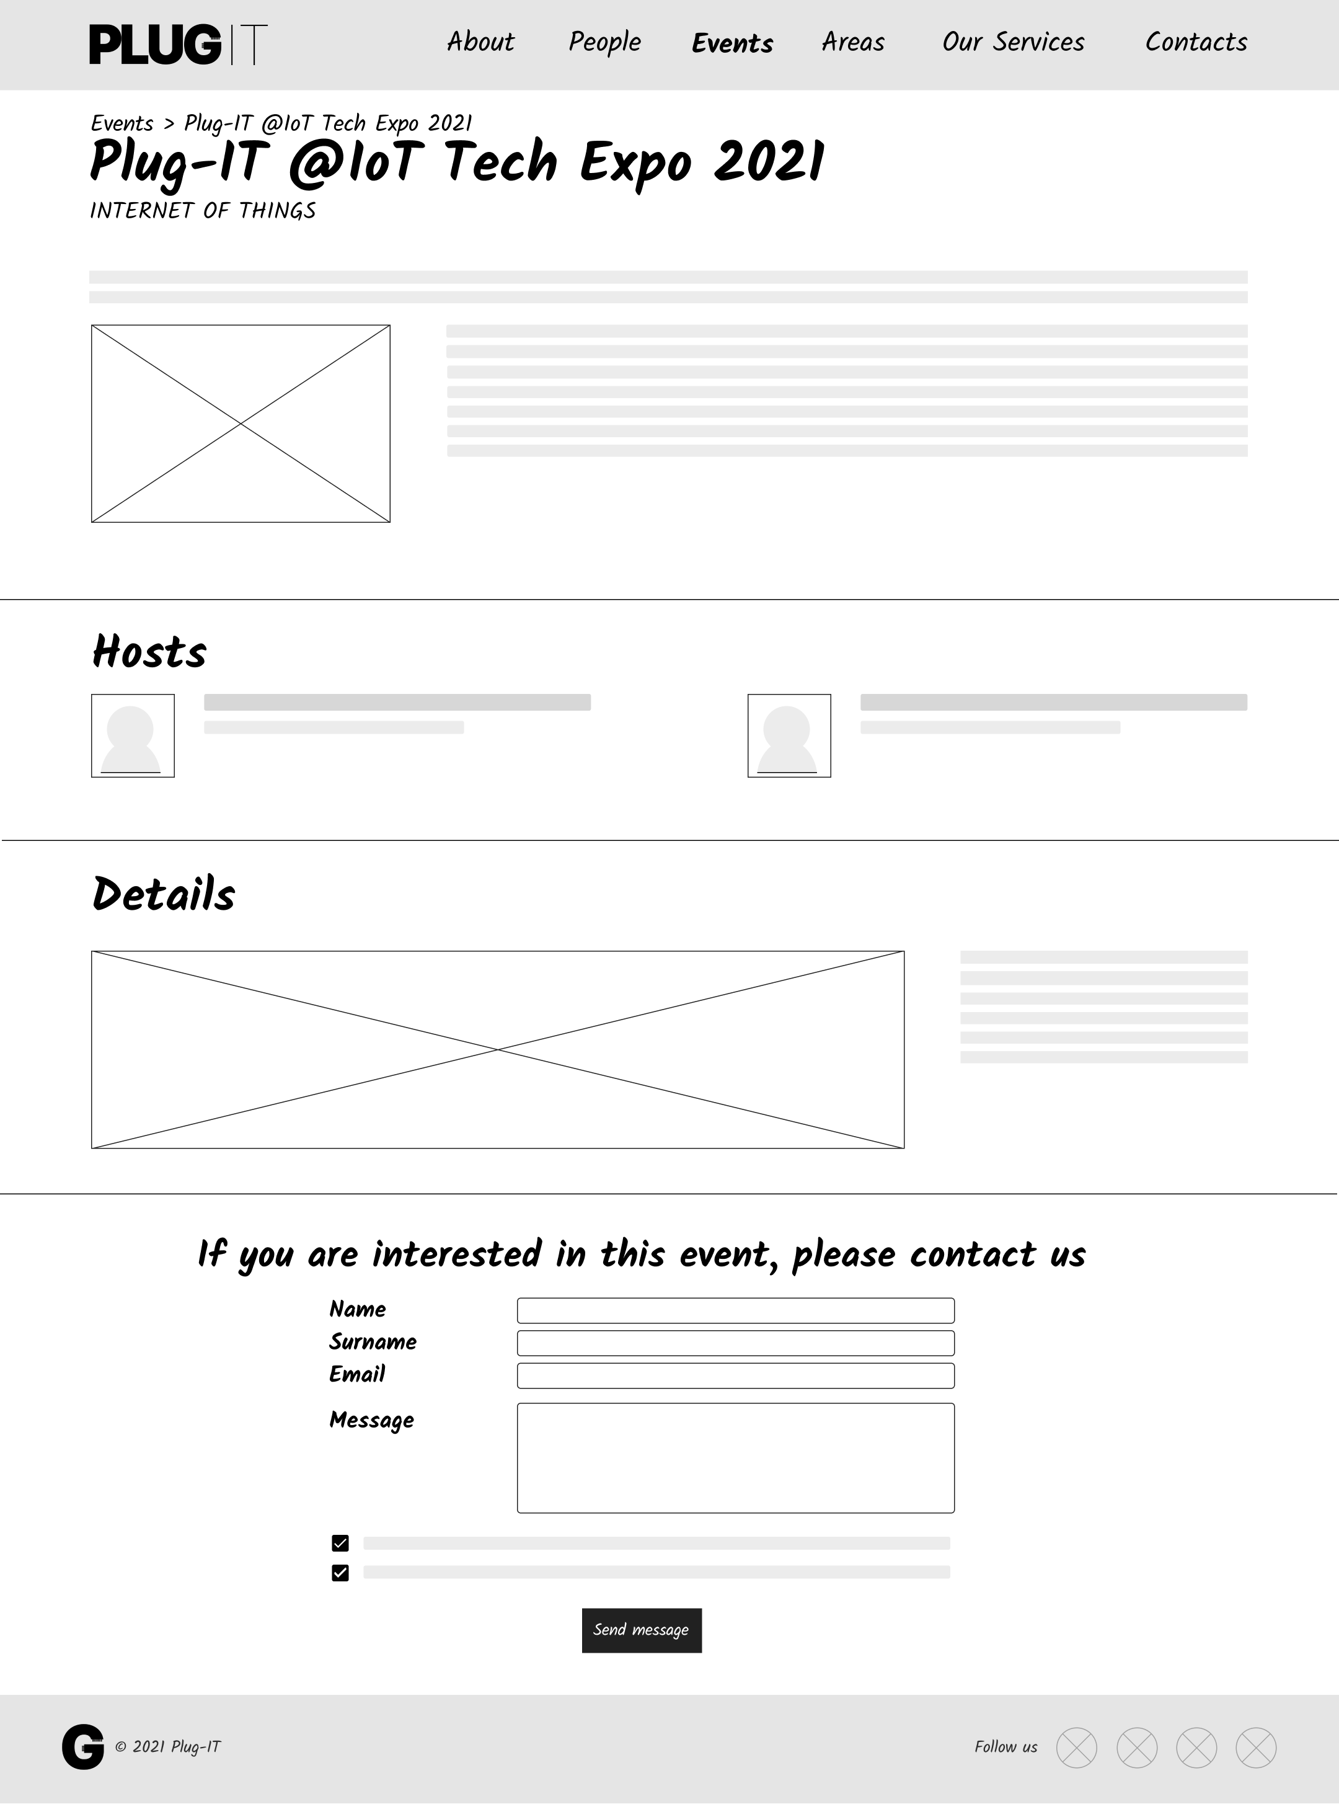

Landmarks

Group link

Transition links

Orientation info

Transition link

Orientation info

Wireframe 11 - Multiple Topic Page: Event Page

Landmarks

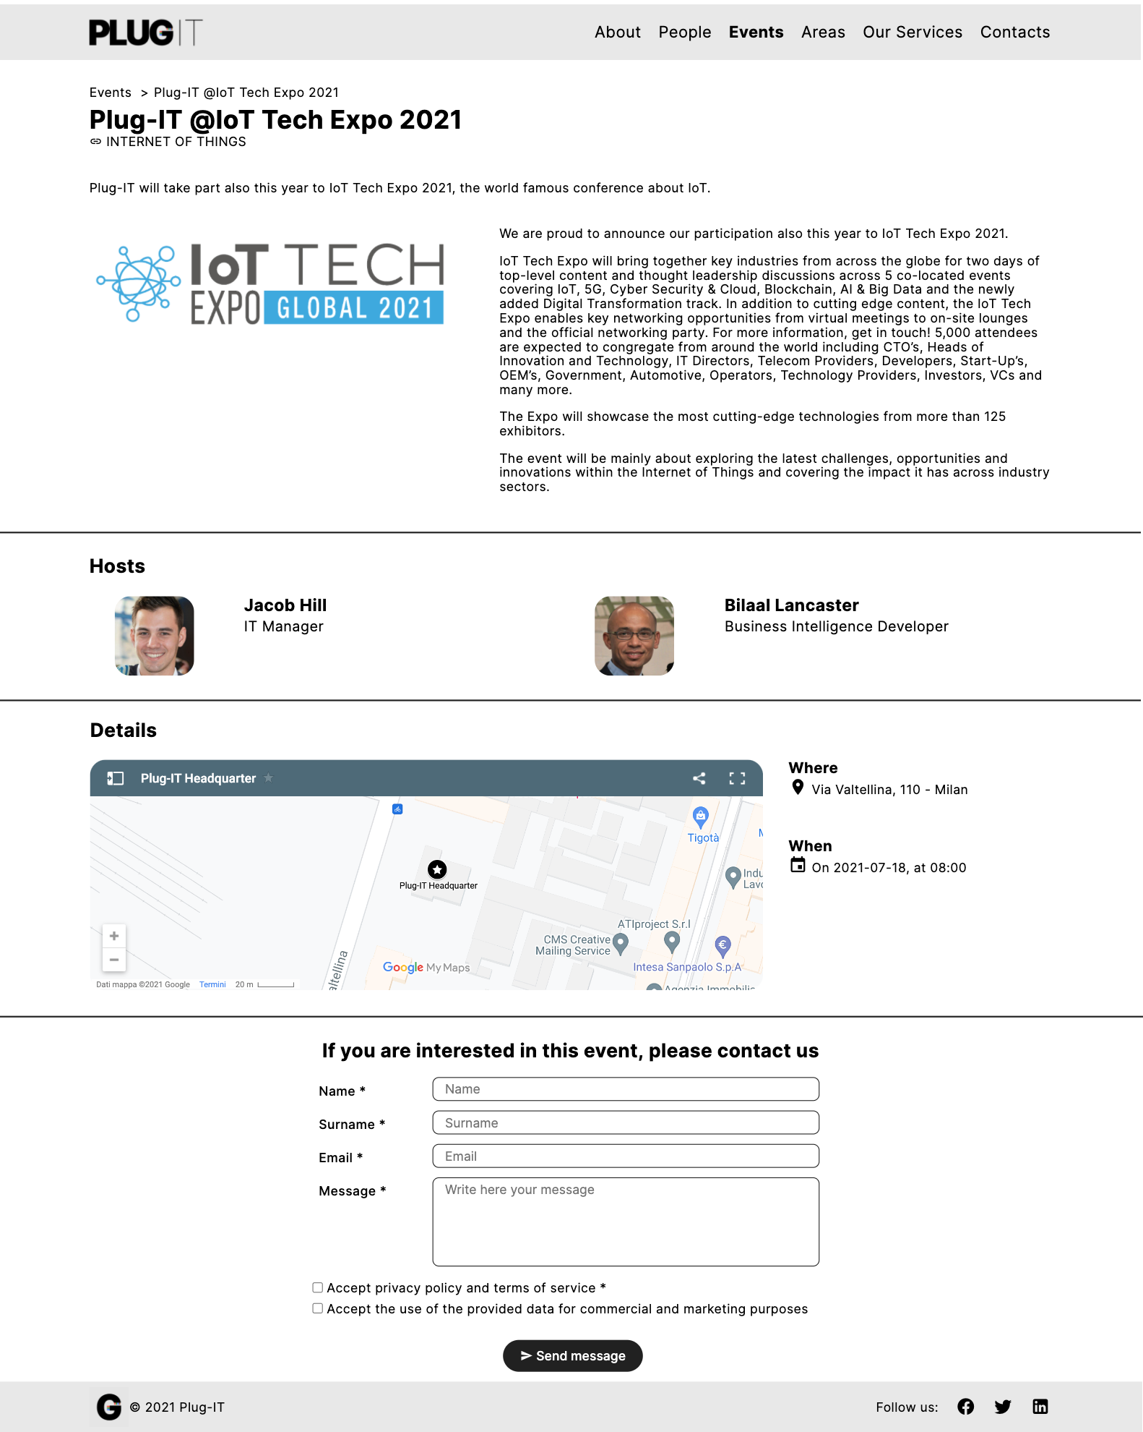

Group link

Orientation info

Transition links

Landmarks

Transition link

Orientation info

Prototype 11 - Multiple Topic Page: Event Page

* 1. **Transition Pages**

This chapter presents the visual design choices related to the *transition pages*, the place where users see the list of topics related to a given page.

### Area Team Page

The *Area Team transition page* displays a set of *transition links* to the personal pages of employees working in a specific area. For each person, the photo, the full name, and the position held in the company are provided. The first link in the grid is the one relating to the area responsible.

Landmarks

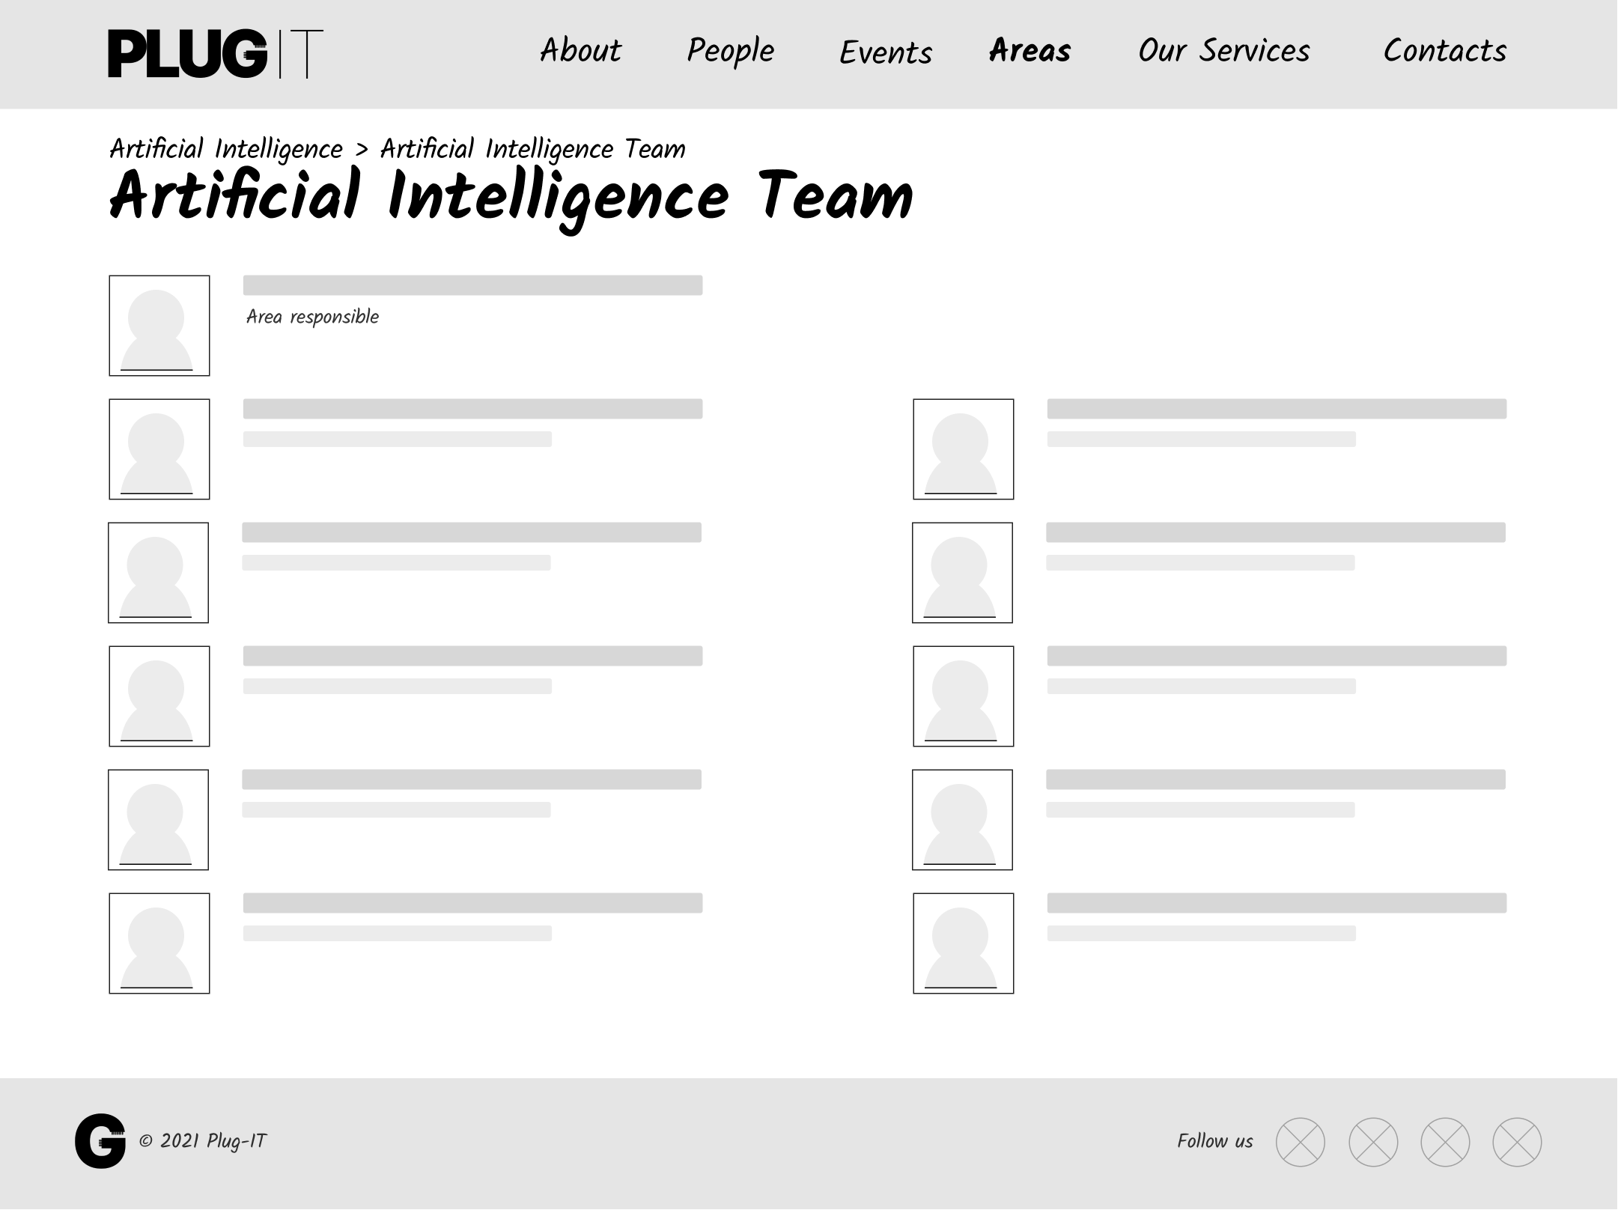

Landmarks

Transition links

Orientation info

Orientation info

Wireframe 12 - Transition Page: Area Team Page

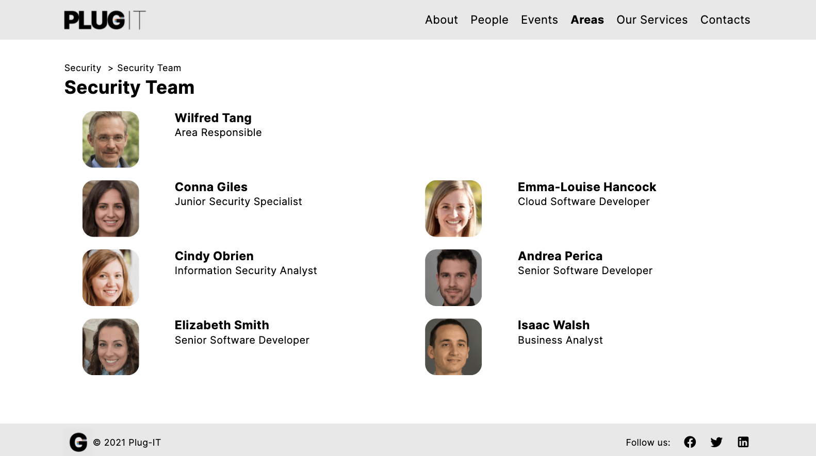

Transition links

Landmarks

Orientation info

Orientation info

Landmarks

Prototype 12 - Transition Page: Area Team Page

### Service Team Page

The *Service Team transition page* displays a set of *transition links* to the personal pages of employees working on a specific service. For each person, the photo, the name, and the covered role are shown. The first link in the grid is the one relating to the project manager.

Landmarks

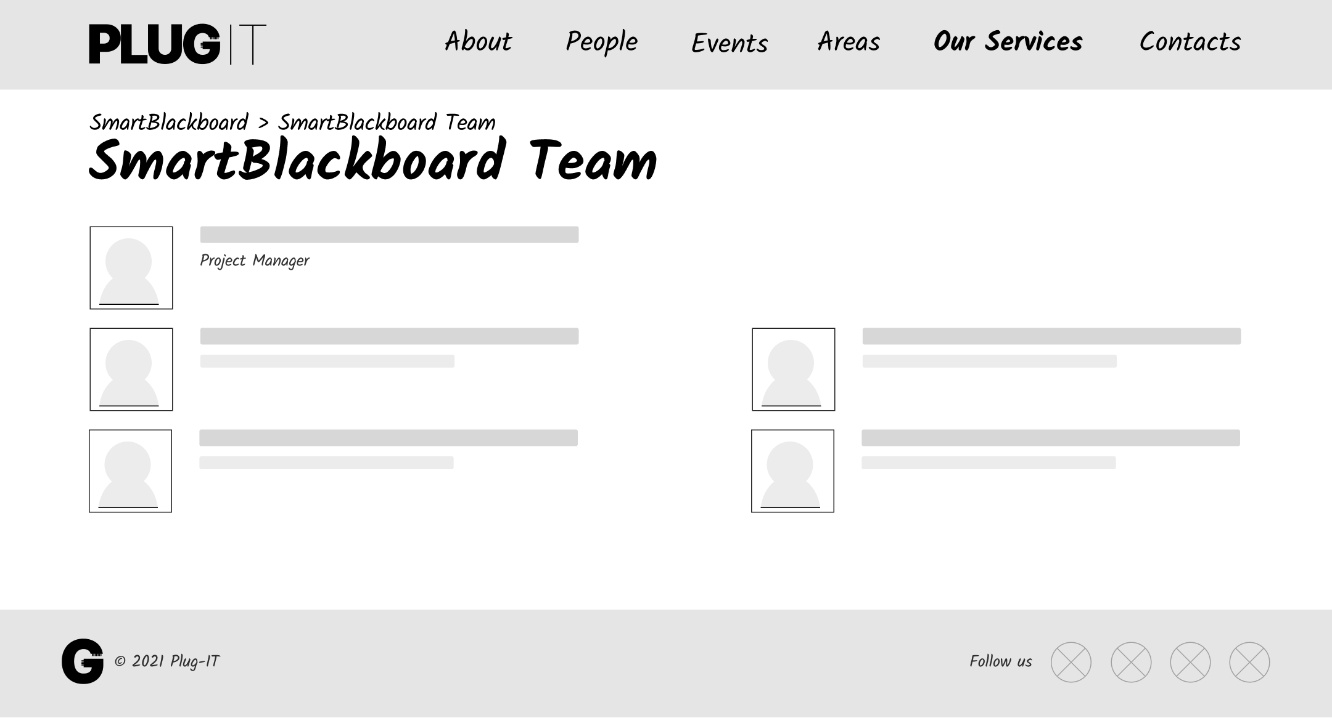

Transition links

Landmarks

Orientation info

Orientation info

Wireframe 13 - Transition Page: Service Team Page

Landmarks

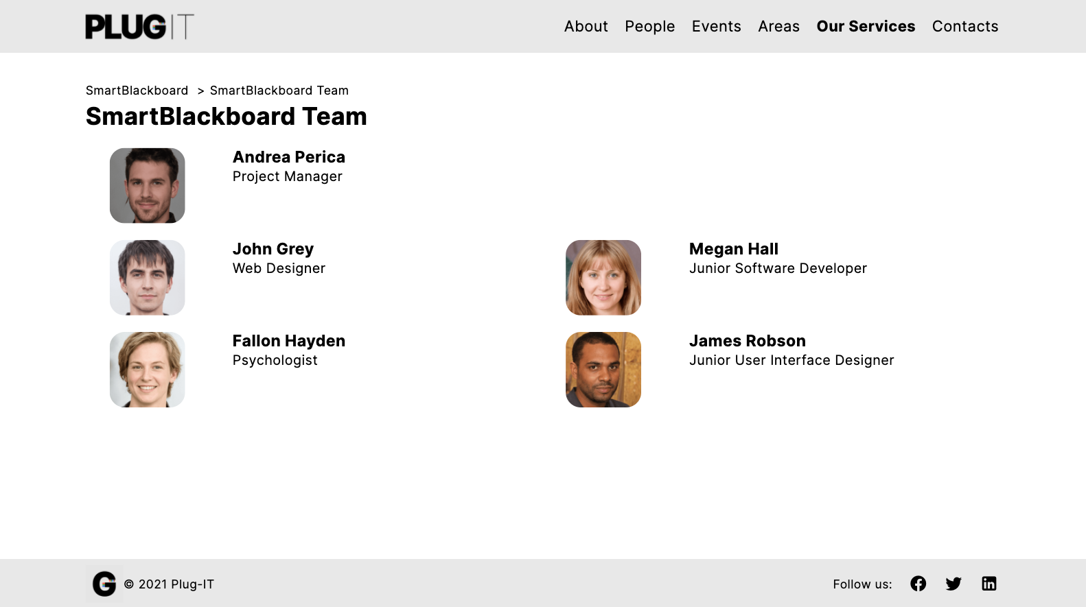

Transition links

Landmarks

Orientation info

Orientation info

Prototype 13 - Transition Page: Service Team Page

1. **Interaction Scenarios**

Use case scenarios exemplify how a typical user is going to use the application. An interaction scenario is a “story of use”; it describes a flow of user interactions across the website for users of a given profile having a specific goal. In the following, for each scenario, is presented a structured textual narrative and a graphical representation of the sequence of required actions. In each screenshot are highlighted the interactive elements activated by the user at each step.

## Use Case 1

#### Textual narrative

|  |  |
| --- | --- |
| **Name** | What about the efforts of *Plug-IT* in Education? |
| **Profile** | The *principal of a school* in Milan is considering improving the technological equipment of her institute. |
| **Goal** | She would like to know the services that *Plug-IT* offers and have an overview of the possible benefits they would bring. |
| **Context** | She visits the website from the computer of her office. |
| **Tasks** | 1. The *principal* accesses the *Home Page* of the website. 2. Being interested in the Education area, she goes to the “*Area”* Page through the navigation bar. Here, she has an overview of the fields in which the company operates. 3. The *principal* then selects the link to the “*Education”* Page. From this section, she discovers the potential of IT in schools and the multiple benefits that *Plug-IT* services would bring. 4. This overview arouses her interest. She now wants to know in detail the proposed solutions. Therefore, she starts browsing the various services in the grid by visiting their respective pages. |

Use Case 1: What about the efforts of Plug-IT in Education?

#### Interaction flow

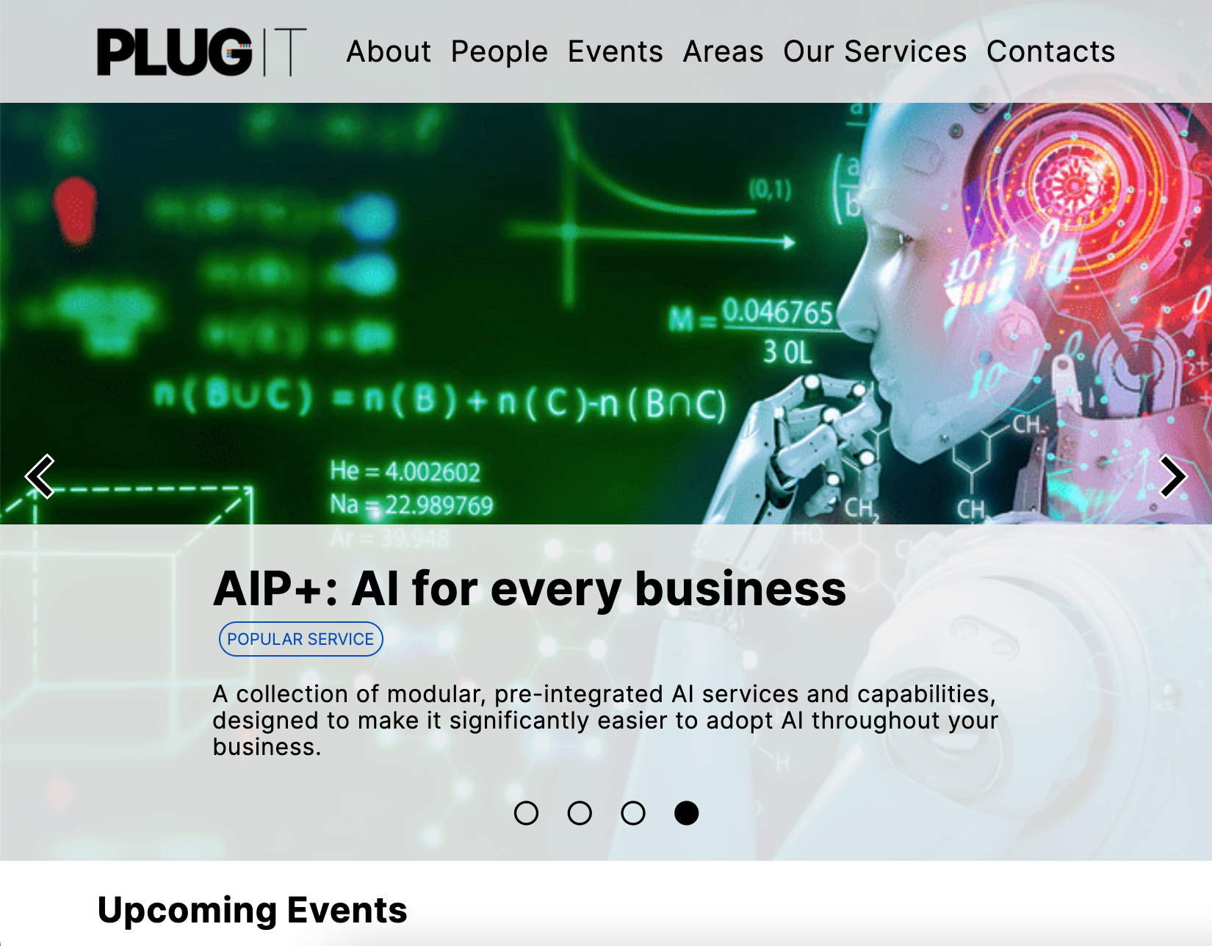 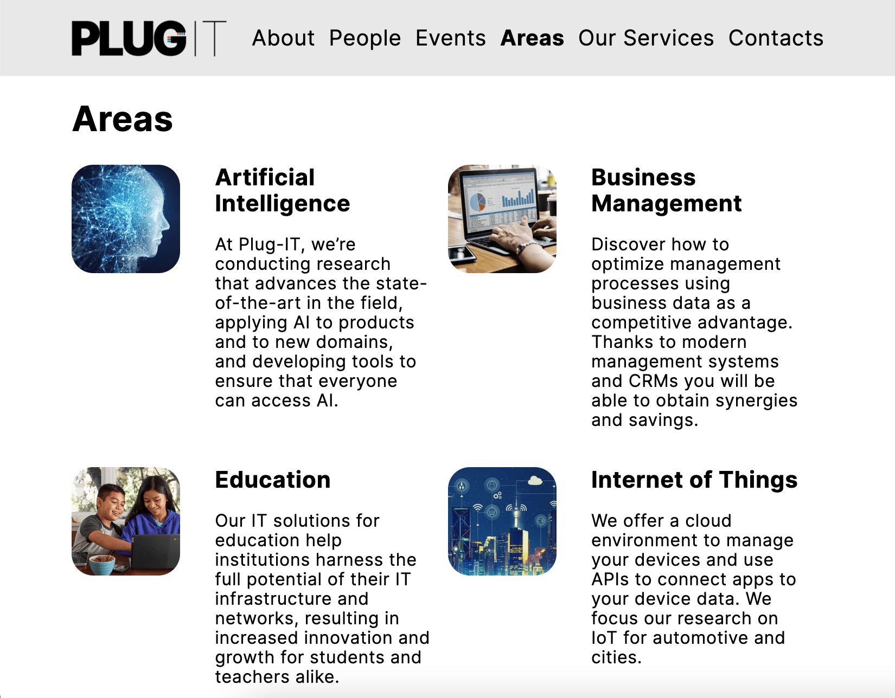

2

1

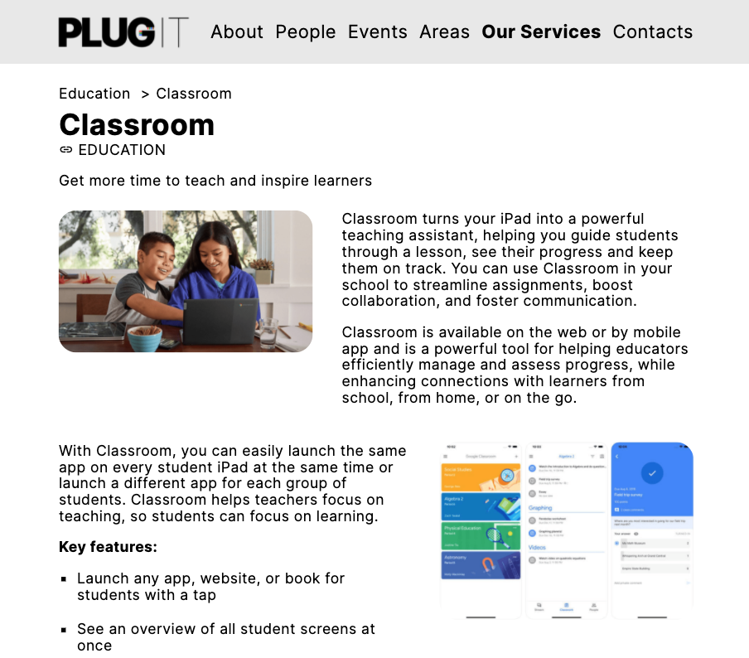

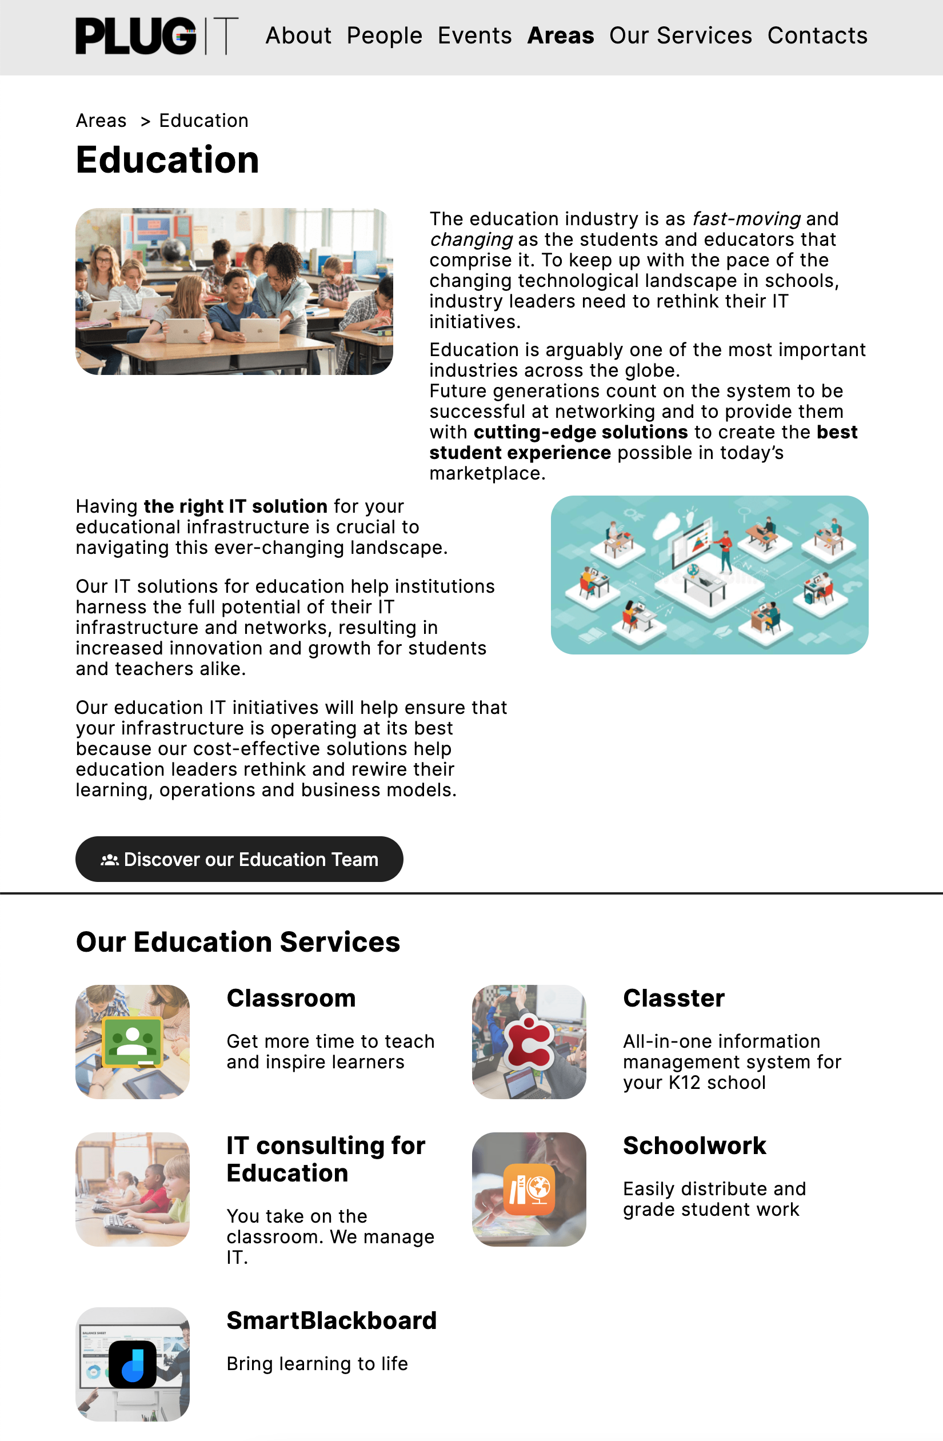

6

3

4

5

## Use Case 2

#### Textual narrative

|  |  |
| --- | --- |
| **Name** | An *IT manager* discovers a new service |
| **Profile** | The board of directors of HomeAppliances asked to improve post-sale support and make it feel more premium. The *IT manager* is in charge to do so. |
| **Goal** | He wants to find a way to make more personal and natural the interaction with the customers, to make them feel more engaged. |
| **Context** | He accesses the website from the desktop computer located in his office |
| **Tasks** | 1. The *IT manager* accesses the *Home Page* of the website. 2. He clicks on “*Our Services*” to check whether there is a service which fits his needs. 3. He realizes that AI solutions can help improve the quality of user-machine interaction and, in general, business indexes. For this reason, he decides to filter the services by area, selecting the Artificial Intelligence field. 4. Among the results shown, he sees “Conversational AI”. From the description displayed below, he realizes that Conversational AI is created specifically for call centers, so it can be used in enterprise call centers, the place where the need for quality of user interaction is most emphasized. He then decides to click on the service to find out more. 5. He reads the description of the service. The *IT manager* is enthusiast. He fills out the form, expressly requesting a demonstration of the product and its potential. 6. He clicks on “Send Message” and sees the confirmation that the message has been sent. |

Use Case 2: An IT manager discovers a new service

#### Interaction flow

 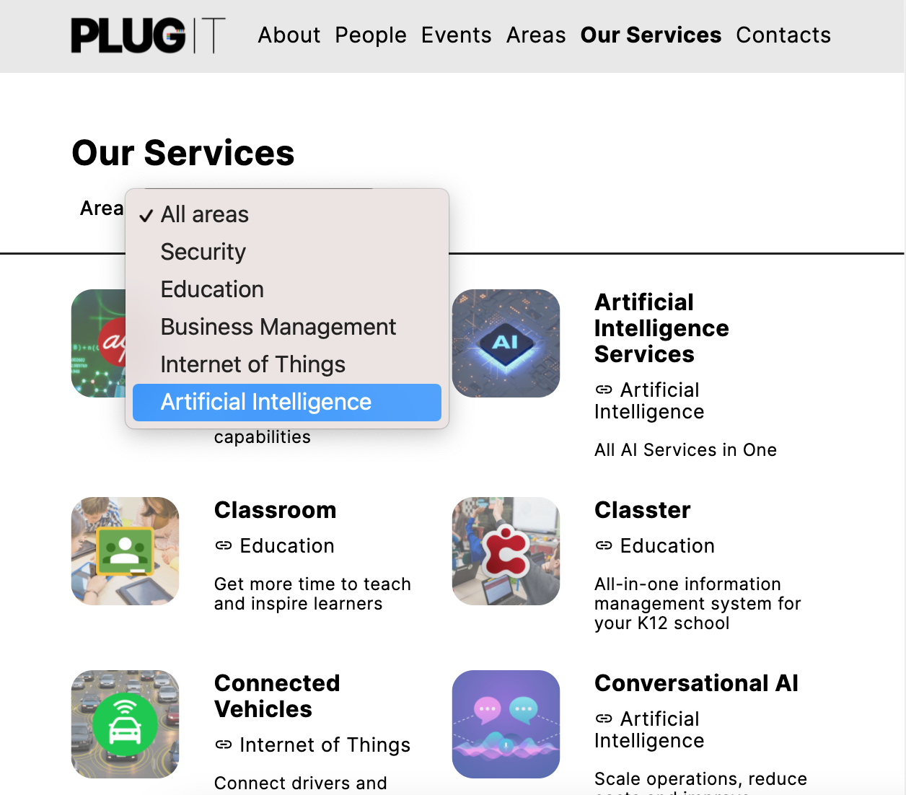

2

1

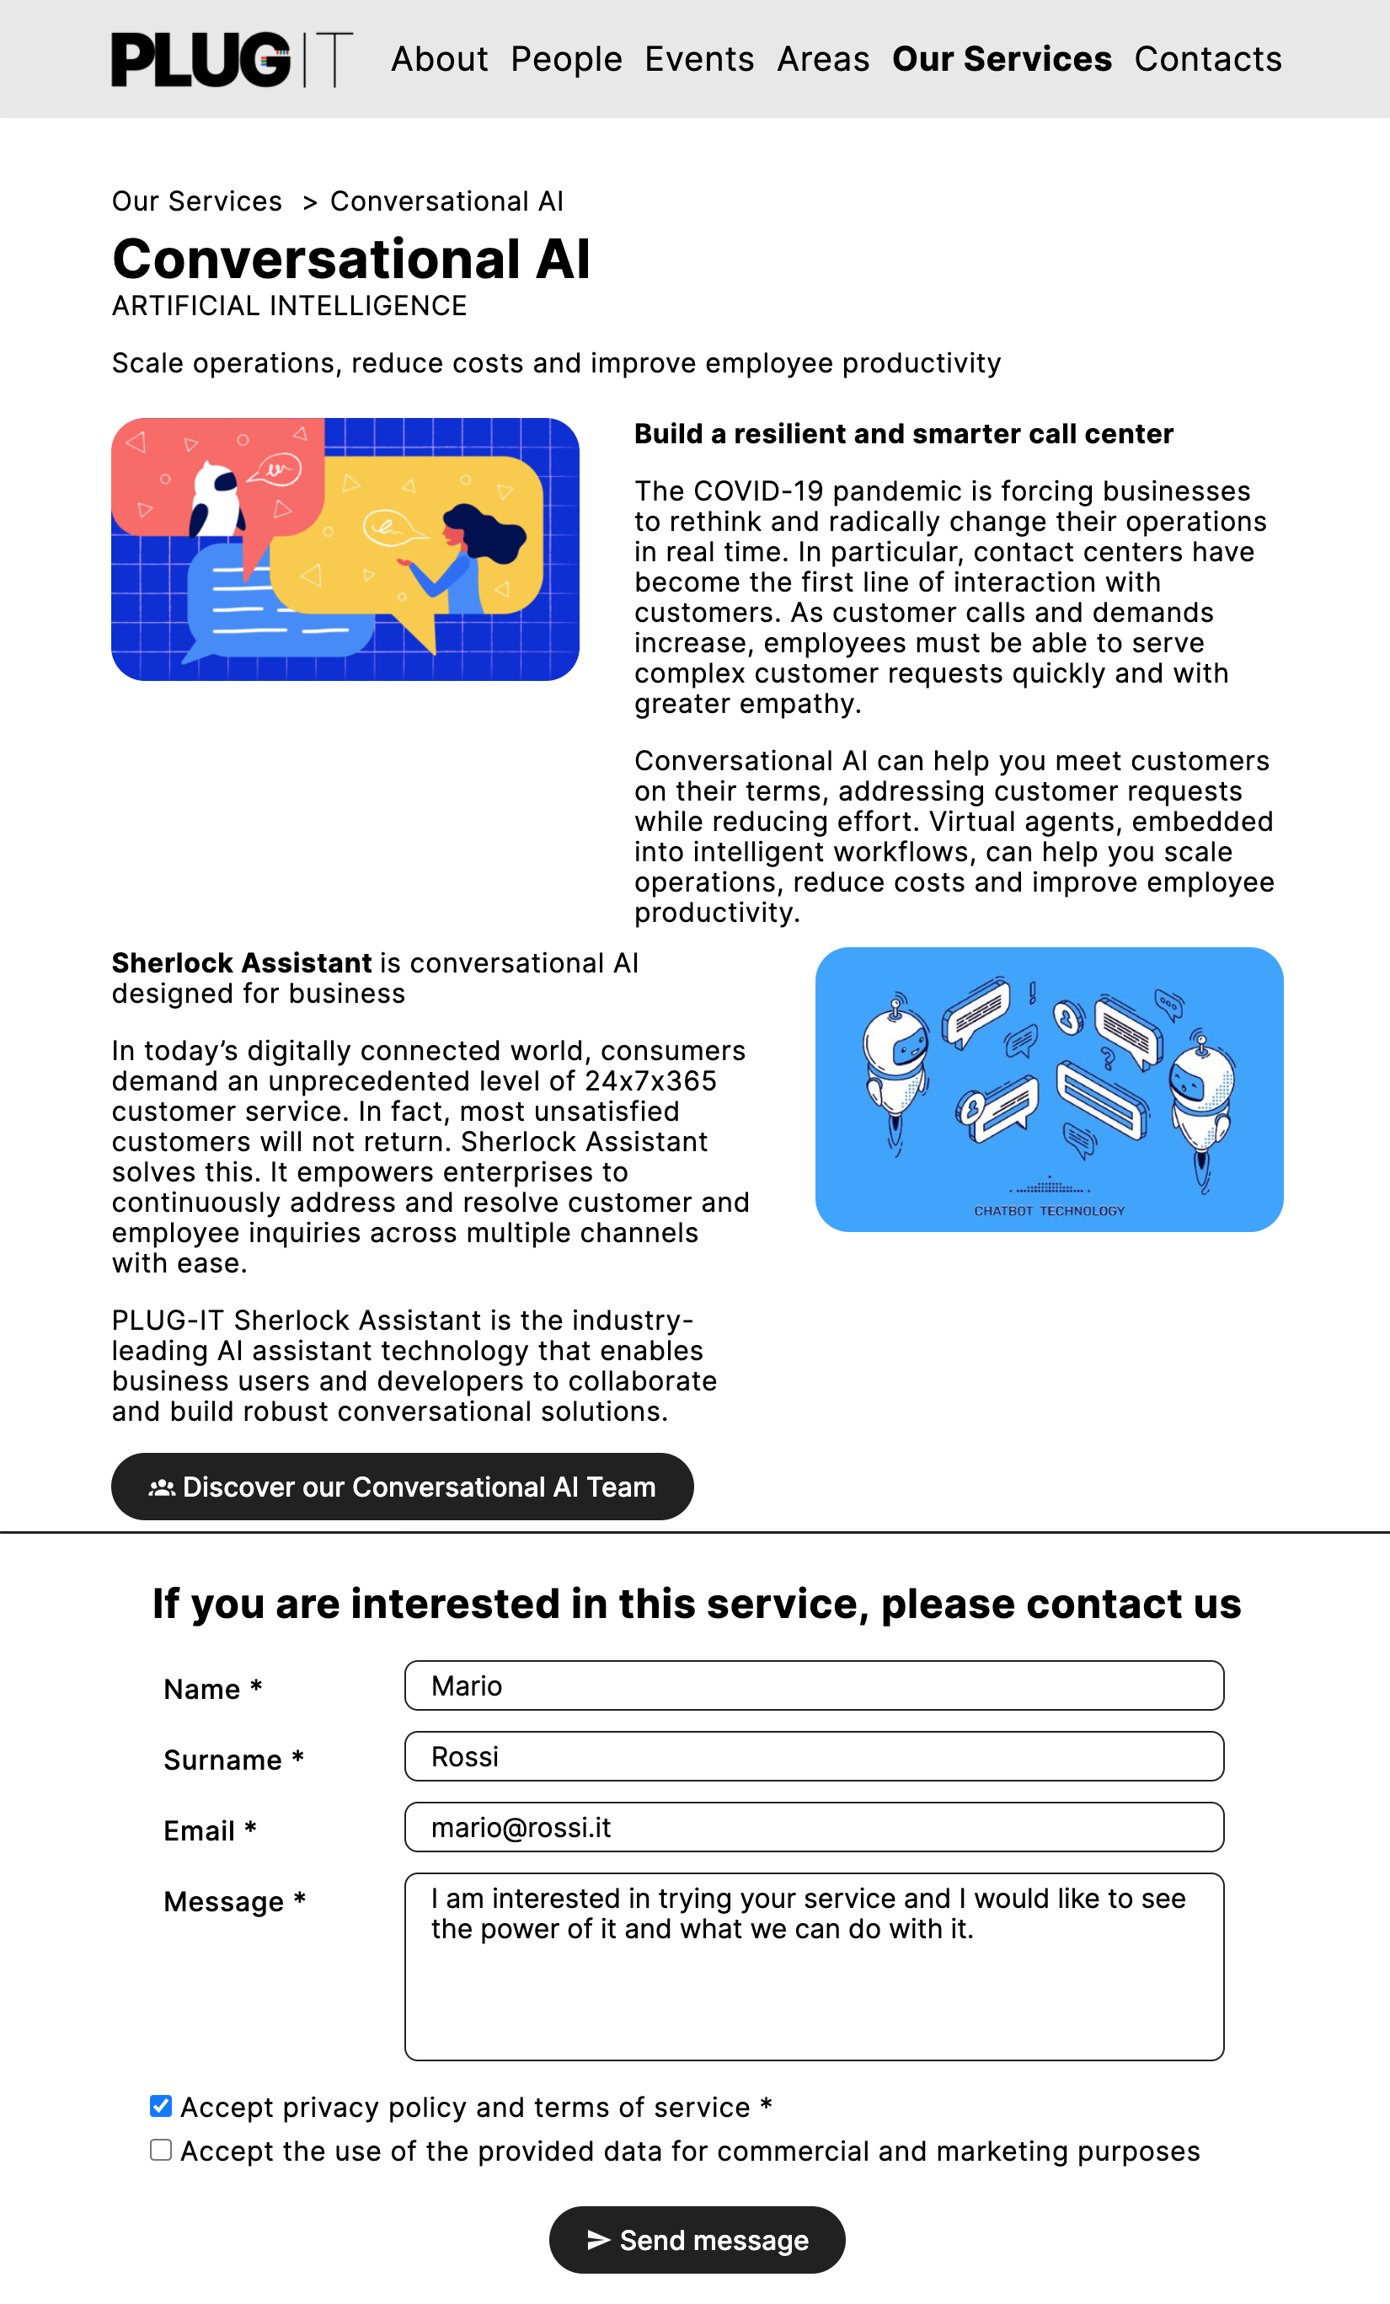

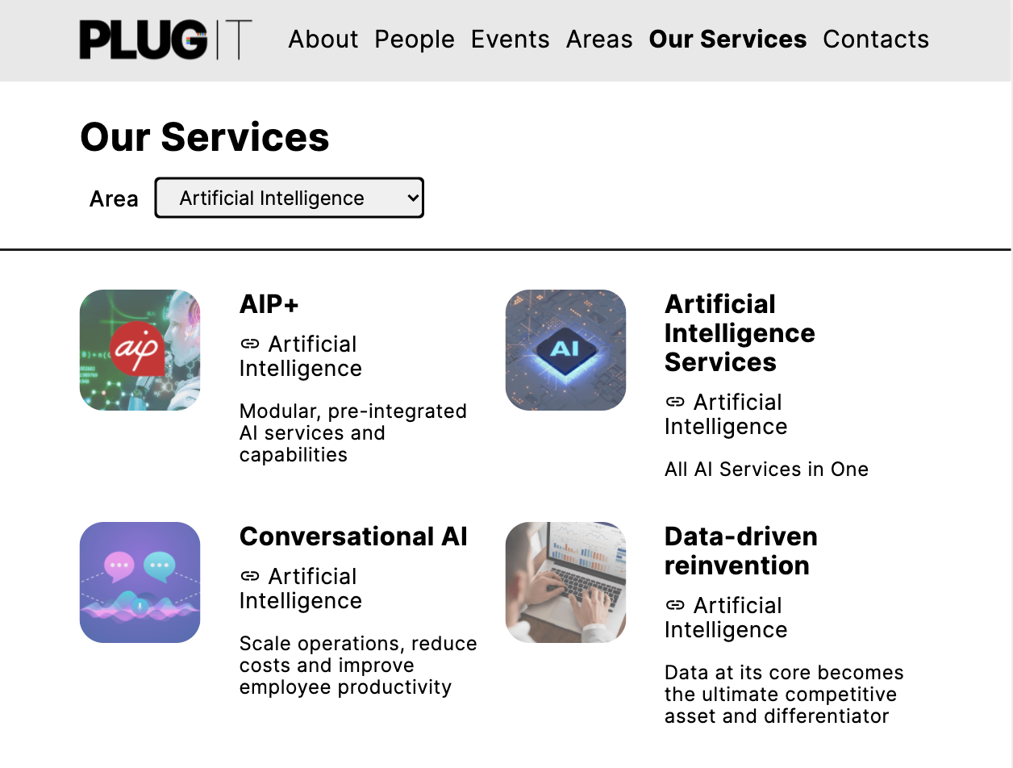

3

5

4



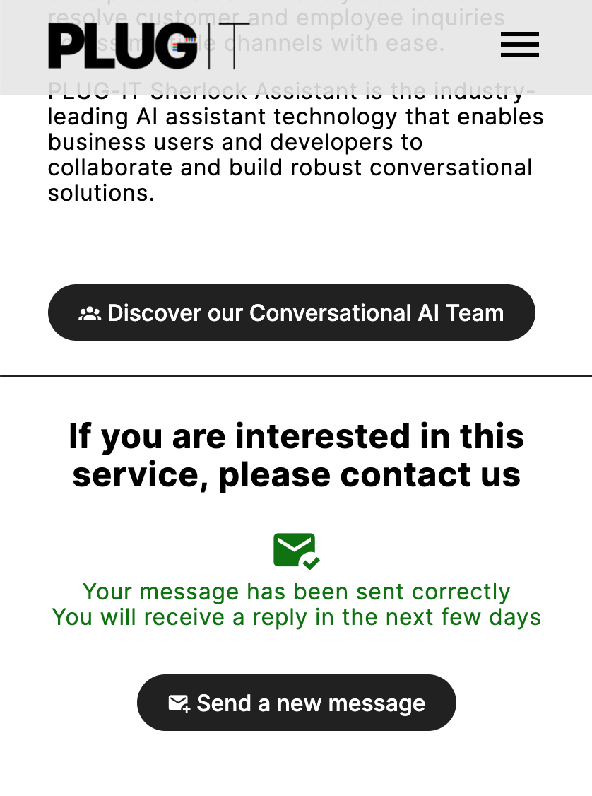

## Use Case 3

#### Textual narrative

|  |  |
| --- | --- |
| **Name** | Get in touch with *Plug-IT* |
| **Profile** | *Tessa* is the *manager* of a medium size IT distribution and support company. She is looking for solid partners to sell their products and services. |
| **Goal** | She wants to gather general information about Plug-IT and contact them. *Tessa* is particularly interested in the history and values of the company. She is evaluating whether Plug-IT could be a potential partner for her company. |
| **Context** | *Tessa* is browsing the website on her laptop. She has already checked Plug-IT services. She thinks they are interesting and can meet the needs of her customers. Therefore, she wants to know more about Plug-IT itself. |
| **Tasks** | 1. The manager is currently on the *Services Page.* 2. She clicks on “*About*” on the header. 3. She starts reading about Plug-IT history which dates up to 1959, making it one of the oldest IT companies out there. She is amused by the lecture and goes on reaching the “*Values*” section. She identifies herself in those values. 4. Once *Tessa* has finished reading, she clicks on the "*Contact us*" button, reaching the *Contact Page.* 5. She fills out the form, expressly requesting a demonstration of the product and its potential. 6. The manager clicks on “Send Message” and sees the confirmation that the message has been sent. |

Use Case 3: Get in touch with Plug-IT

#### Interaction flow

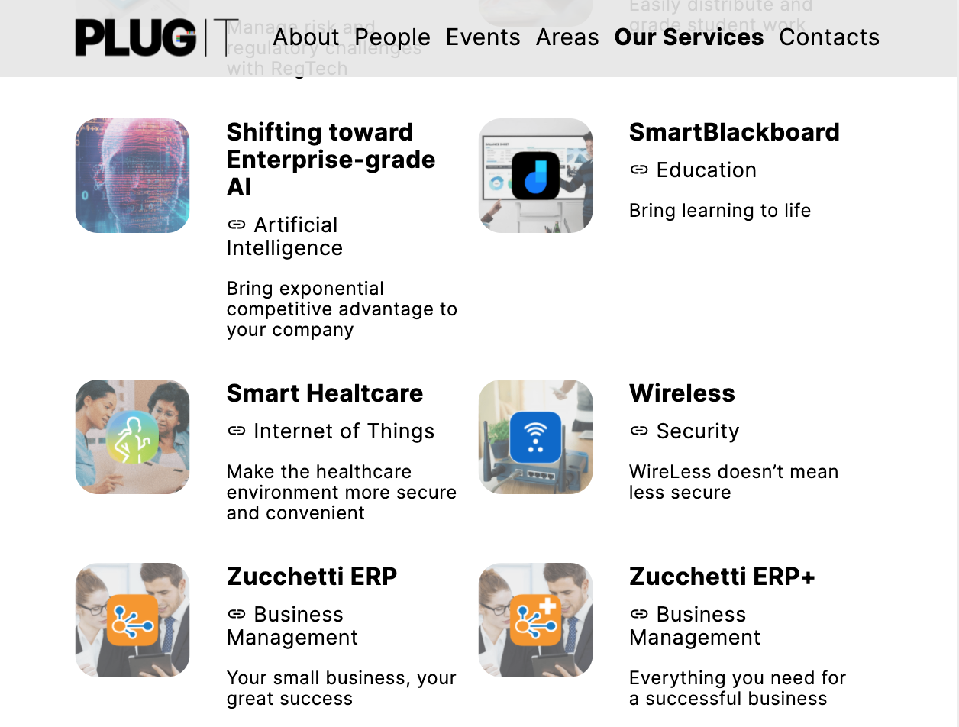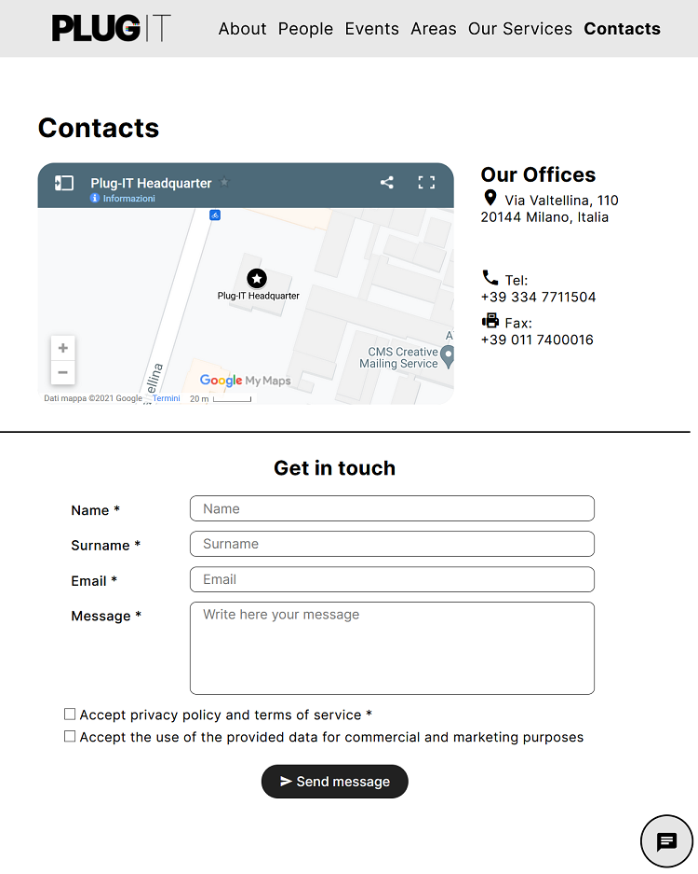 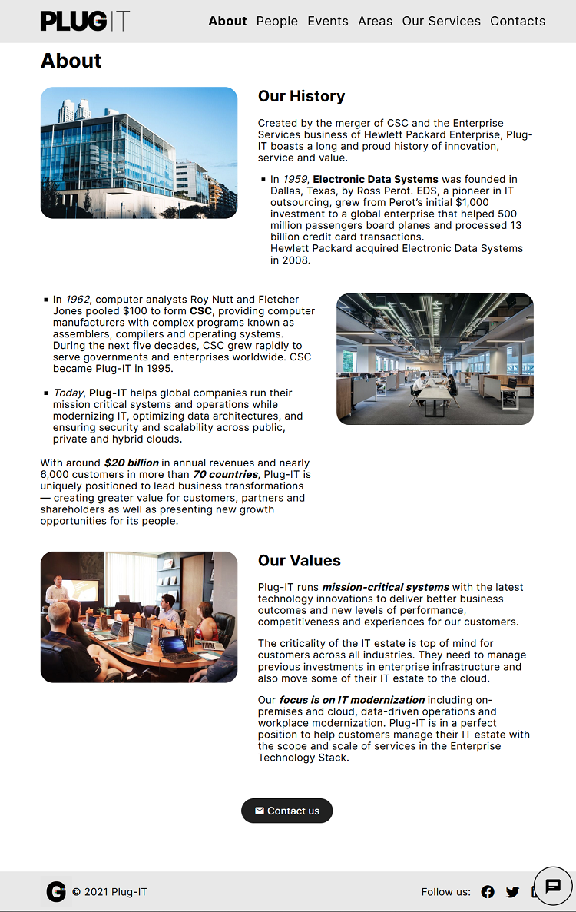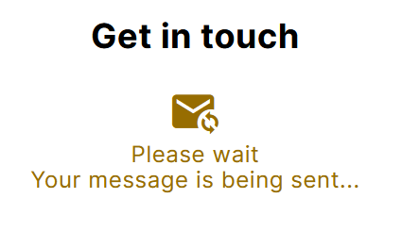

1

2

5

4

3

## Use Case 4

#### Textual narrative

|  |  |
| --- | --- |
| **Name** | Finding out about an event |
| **Profile** | Anna is a young woman with an 8-year-old son. She is really interested in the world of technology. |
| **Goal** | She wants to find out about an event. |
| **Context** | In this period, Anna’s son is attending school lessons from remote due to the pandemic. Although she loves technology, she is not so enthusiast about it because she is concerned about the possible negative consequences.  Anna is browsing Plug-IT website since she is a tech addict. She is using her gaming desktop computer. |
| **Tasks** | 1. Anna is browsing Plug-IT website since she is a tech addict and likes to keep update with Plug-IT latest news and products. 2. Her attention is captured by the “Events” section: she clicks on “*Events*” on the header 3. She sees an upcoming event called “*How to better protect and empower our kids*”. She is a young mom so she would like to read more about it. She clicks on the event title. 4. She reads the event’s description. She finds out that it is mainly about benefits and risks of children using the computer, with a particular focus to the current situation due to COVID-19. She also read the details about place and time of the event. 5. She would like to know even more about it, so she fills the form to ask further questions about the organization of the event. 6. She clicks on “Send Message” and sees the confirmation that the message has been sent. |

Use Case 4: Finding out about an event

#### Interaction flow

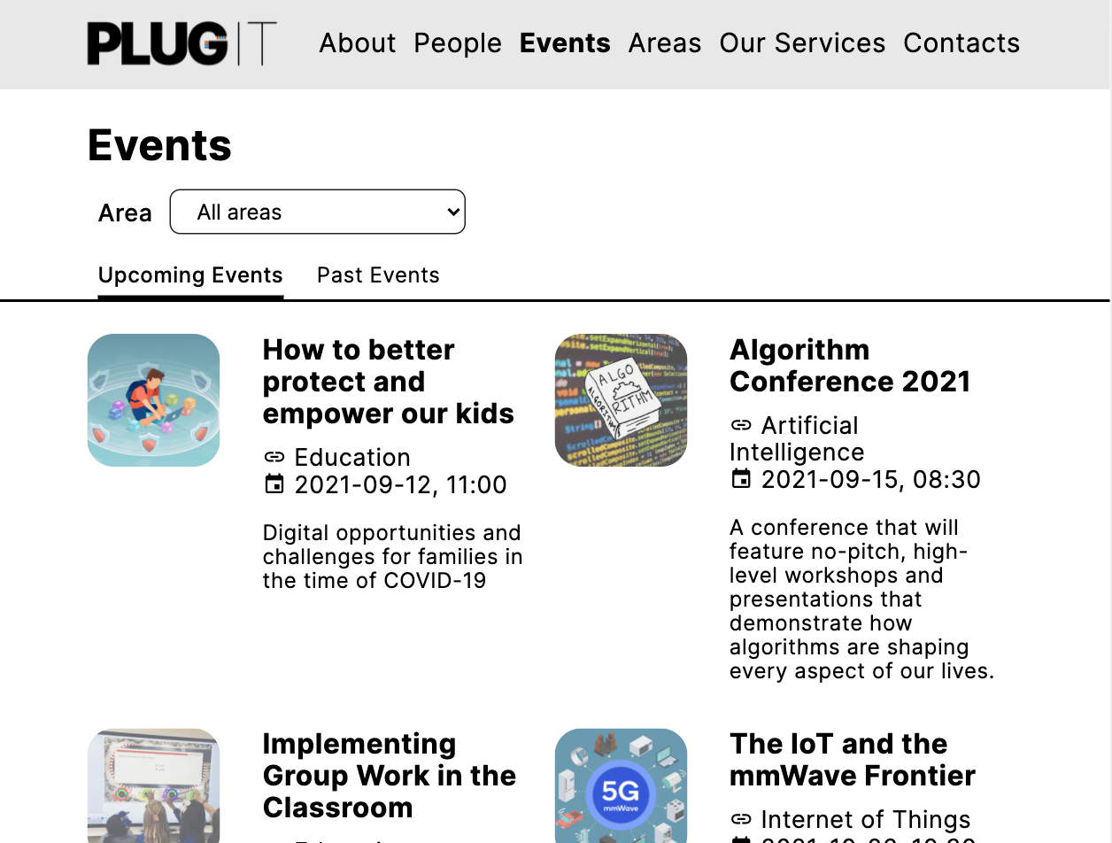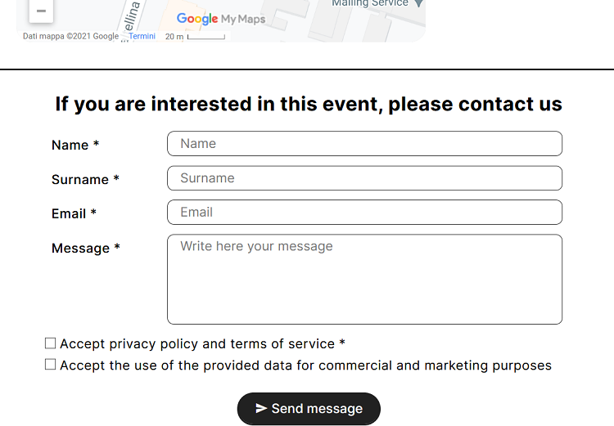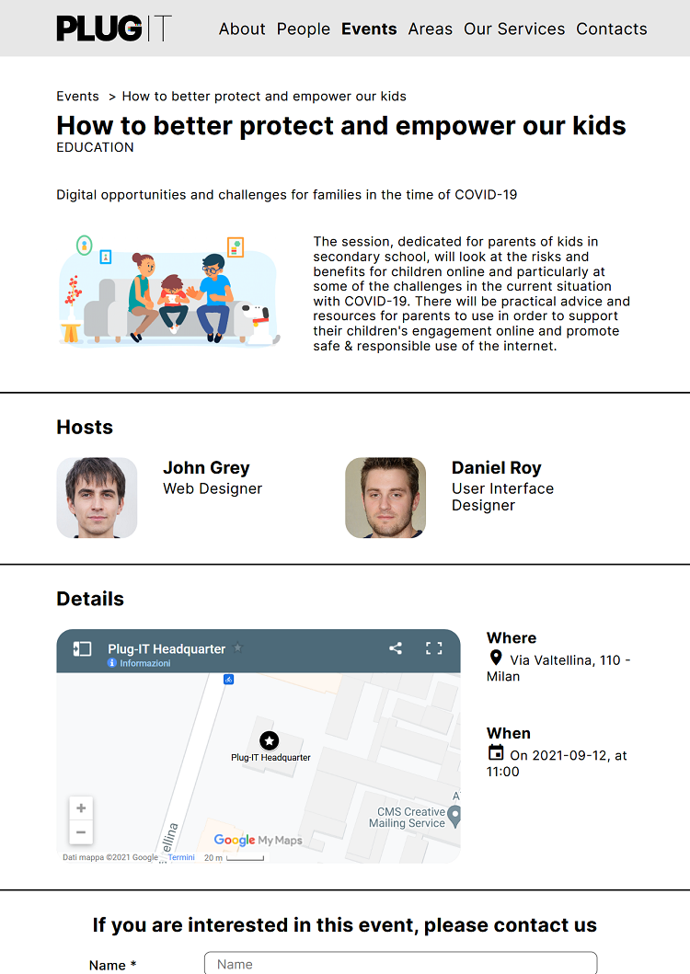

5

4

3

2

1

## Use Case 5

#### Textual narrative

|  |  |
| --- | --- |
| **Name** | Discovering the team |
| **Profile** | A *customer* is interested in the services that a *Plug-IT* employee has worked on. |
| **Goal** | He would like to know the services that a *Plug-IT* employee has worked on, and the role played in them. |
| **Context** | He visits the website from its tablet. |
| **Tasks** | 1. The *customer* accesses the *Home Page* of the website. 2. Being interested in the team behind *Plug-IT*, he clicks on “*People*” in the navigation bar. Here, all employees are shown to him. 3. Once he has found the employee he was looking for, he clicks on her photo. This leads him to the profile page, where in addition to the biography, he can find all the information about the areas and services in which the woman works. |

Use Case 5: Discovering the team

#### Interaction flow

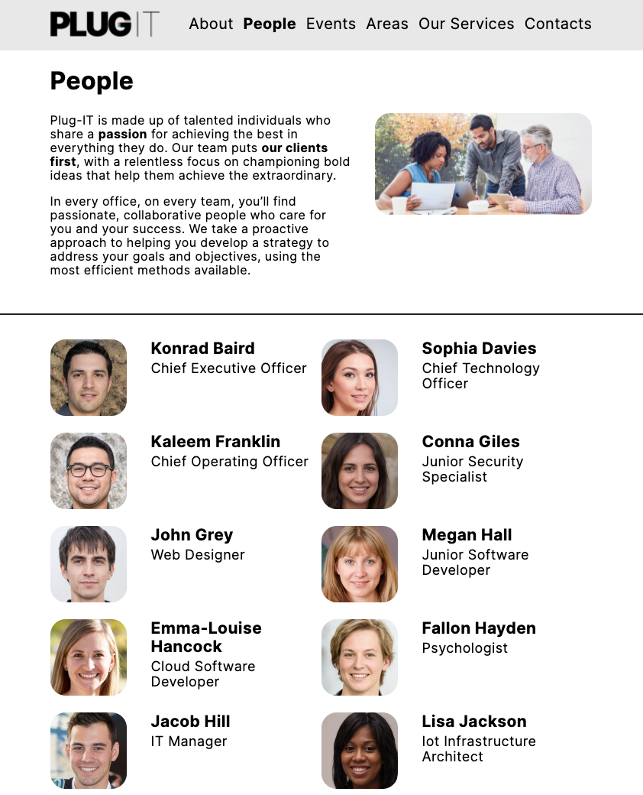



1

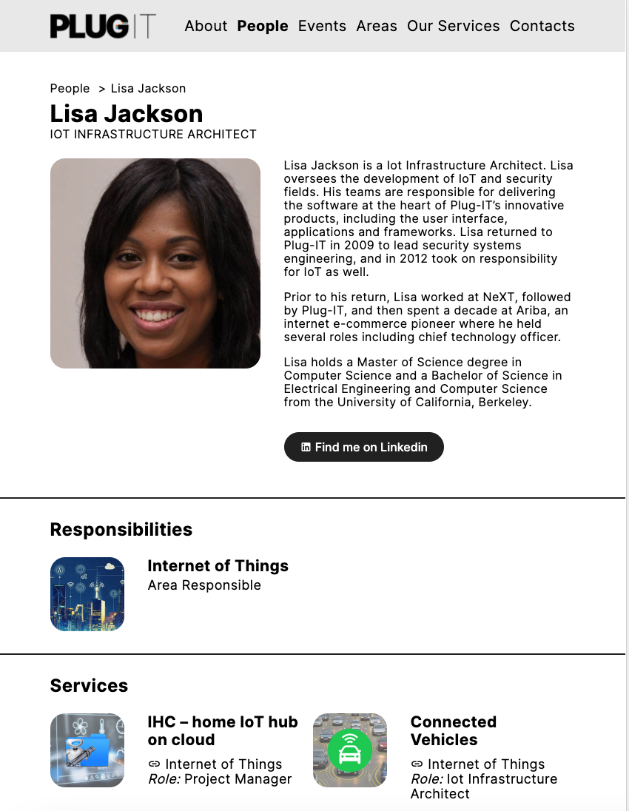

2

**Database Design**

This chapter provides details of the database design for the website to be implemented. First, the conceptual model will be represented through an *ER-diagram*. A tabular representation of the logical model will then be provided.

* 1. **Entity-Relationship Diagram**

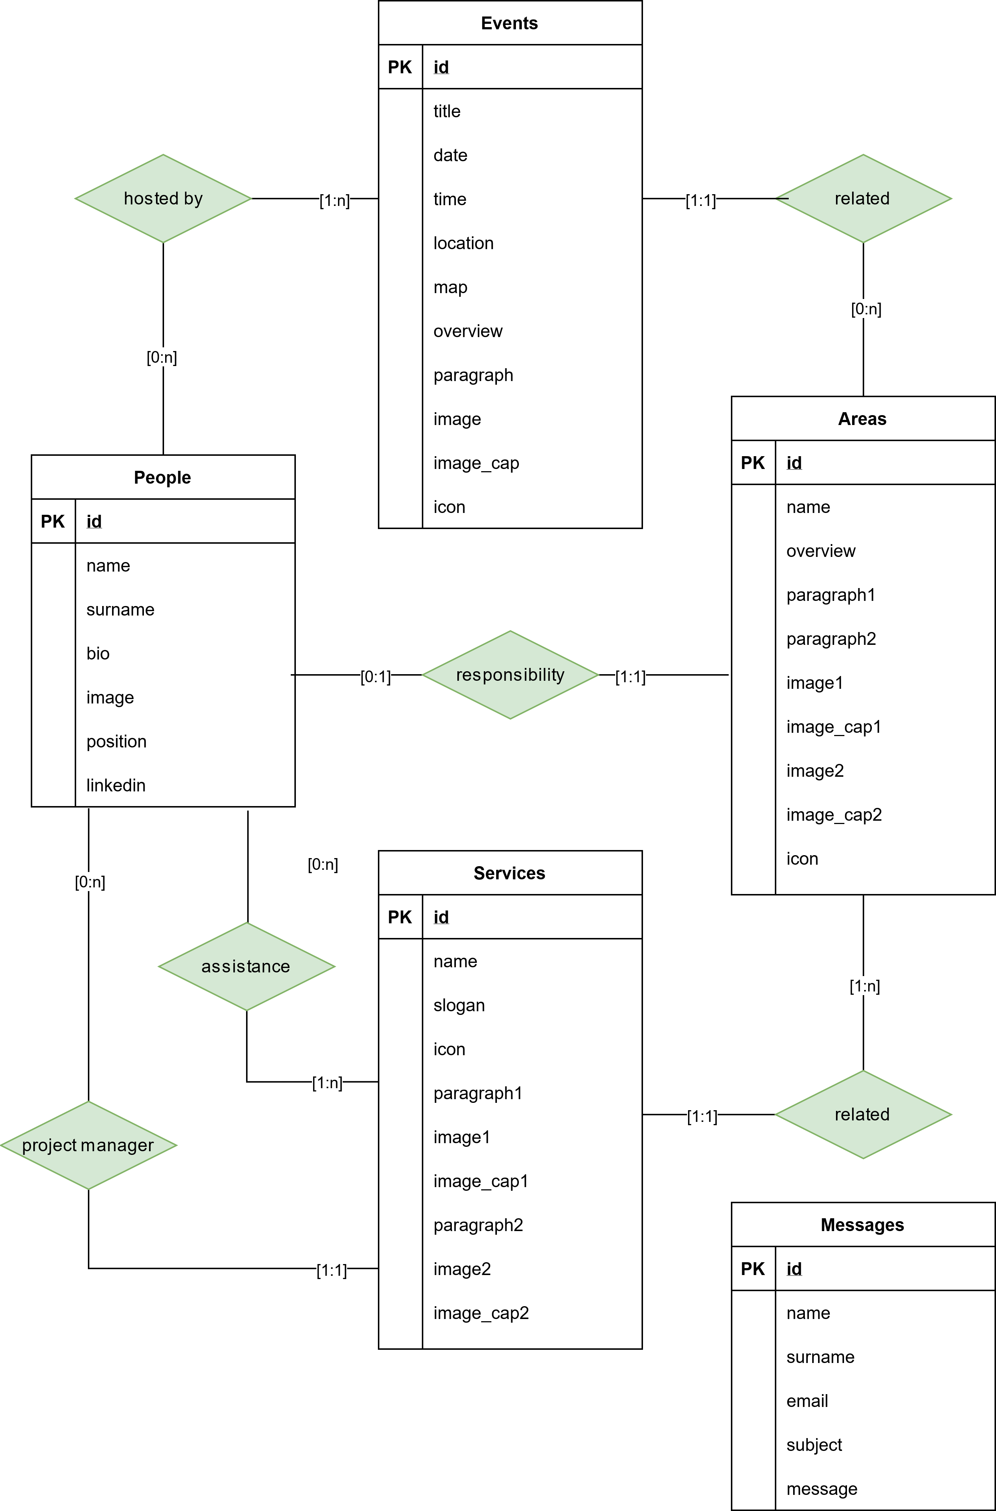

ER Diagram

* 1. **Relational Tables**

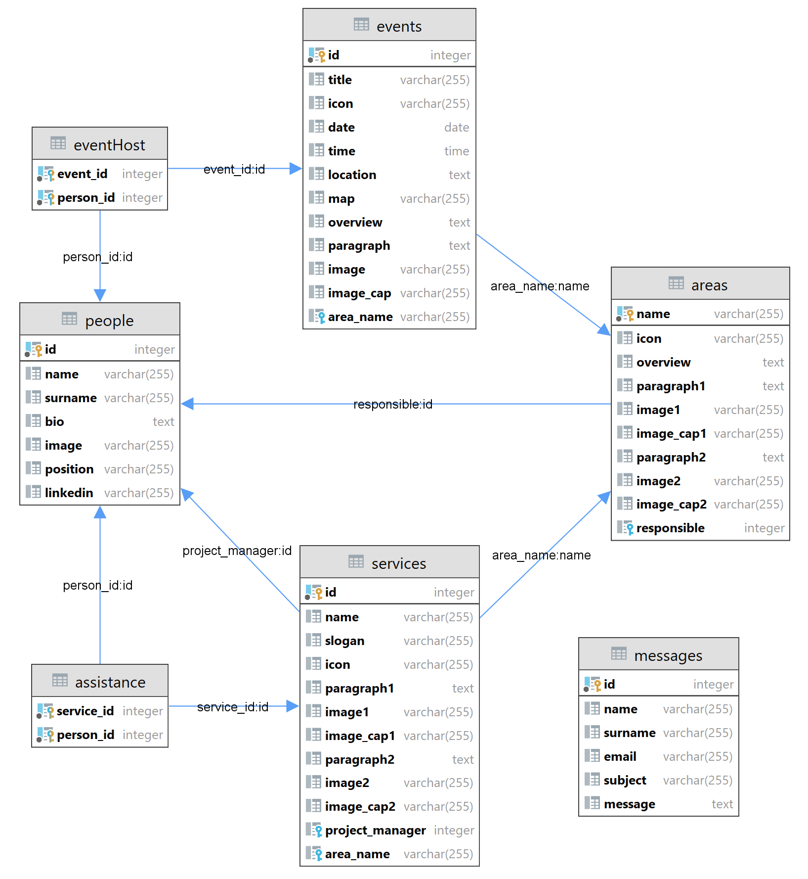

Logical Diagram